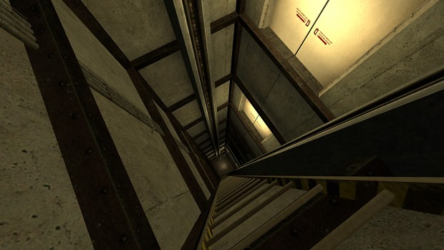

Half-life 2: Critical Fall

Version 2.0

|  |  |
| --- | --- |
| Designer: | Layne Zhang |
| Document Date: | Dec 7th, 2022 |
| Intended Level Delivery Date: | Dec 5th, 2022 |

**Document Revisions Table**

|  |  |  |  |
| --- | --- | --- | --- |
| **Version** | **Description** | **Requestor** | **Date** |
| 1.0 | Initial Document | Professor Ouellette | Oct 29, 2022 |
| 2.0 | * Redesigned maps * Updated Level Feature Overview * Rewrote level information section (Level Maps) * Updated skill progress chart * Updated New Skills/Gameplay Mechanics * Rewrote hooks and gameplay section * Updated Context Backstory, Aesthetic References, Key Asset Needs, Unique Tasks, and References to reflect the current version | Professor Ouellette | Dec 7, 2022 |
|  |  |  |  |
|  |  |  |  |

# Table of Contents

Table of Contents 2

Table of Figures 3

Level Information 4

Quick Summary 4

Level Feature Overview 4

Level Map(s) 6

Overview Map 6

Higher floor - fall 10

Lower floor 13

Elevator rising up 19

Higher floor - return 21

Skill Progression Chart 28

New Skills/Gameplay Mechanics 29

Hook(s)/Gameplay Highlights 31

Context 31

Backstory 32

Aftermath 32

Development Schedule 32

Aesthetic References 33

Visual Theme 1: Warehouse & factory & office & open area and layout 33

Visual Theme 2: Parking lot & forest & highway and layout 34

Unique Requirements and Risks 34

Key Asset Needs 36

References 38

# Table of Figures

Figure 1: Overview Map [11] 6

Figure 2: Legend [11] [12] 6

Figure 3: Top-down view of the map structure 6

Figure 4: Top-level summary [11] 7

Figure 5: Higher floor - fall Walkthrough [11] 10

Figure 6: Lower floor Walkthrough [11] 13

Figure 7: Elevator Walkthrough [11] 19

Figure 8: Higher floor return Walkthrough [11] 21

Figure 9: Skill Progression Chart 28

Figure 10: Contact Sheet for Visual Theme 1 [1 – 6] 33

Figure 11: Contact Sheet for Visual Theme 2 [7 - 10] 34

Level Design Document

# Level Information

## Quick Summary

“Critical Fall” is a single-player shooter level in *Half-life 2*. After the battle at highway 17, Dr. Freeman is captured in the ambush of a group of Combine Elites and is locked up at a prison block inside of the Nova Prospekt, waiting to be executed soon. An undercover Resistance soldier is tasked by Alyx to hide Freeman by transferring him to another safe room. However, shortly after that the facility notices and reports the missing of Dr. Freeman and starts the lockdown for the whole building. Now, finding a way out and reunion with Alyx is left to Dr. Freeman.

The player experience will focus on utilizing moving platforms to crush enemies, sending explosives and the player to another position, creating bridges, and obtaining resources (covers & explosives), by using triggers to control their movement (some require a battery to activate the trigger before they are available to use) & cutting ropes connected to it to let it fall. Aside from that, cover shooting, resource management, battery puzzles & moving platform puzzles are also highlighted.

## Level Feature Overview

|  |  |  |
| --- | --- | --- |
| Category | Sub-Category | Feature List |
| Player | Player Weapons | * SMG (with Grenade as a second fire) * Crowbar |
|  | Player Skills/Abilities | * Explosion shoot (explosives) * Cover shooting * Platforms (moving platform & hanging platform)   + Crush   + Bridge   + Resource drop (Explosives, cover) * Puzzle solving   + Moving platform   + Battery * Weapon switch * Delivering explosives (moving platform + explosives + shoot/grenades) |
| AI | Enemies | * Combine Soldier (SMG) * Combine Soldier (Shotgun) |
|  | Friendlies | * Alyx |
| Challenges | Gameplay Themes | * Platform * Battery * Explosive |
|  | Obstacles/Hazards | * Platform crush * Explosion (explosives & grenades) * Floor break * Goo |
|  | New/Unique Gameplay | * Platform control   + Crush   + Bridge   + Resource drop (Explosives, cover) * Moving platform puzzle * Combat on the elevator (in the process of getting back to the top floor) |
| Aesthetics | Setting (visual theme) | * Warehouse/ factory (Nova Prospekt, within Combine’s building, since Gordon was transferred from prison block to the warehouse office) |

## Level Map(s)

### Overview Map

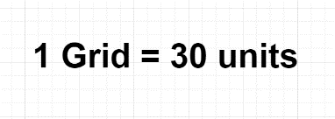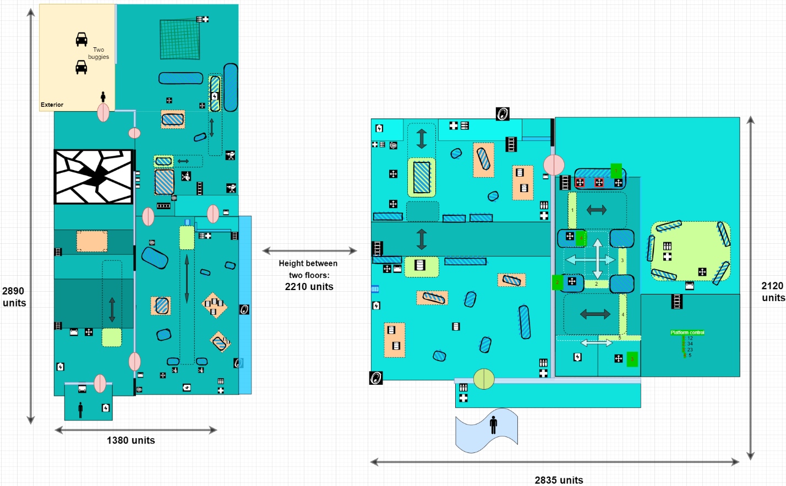

Figure : Overview Map [11]

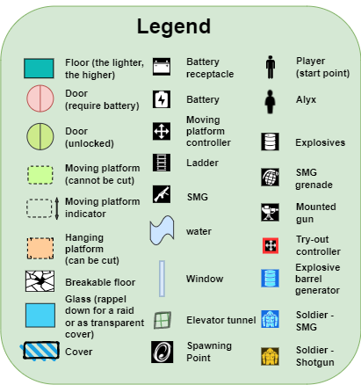

Figure : Legend [11] [12]

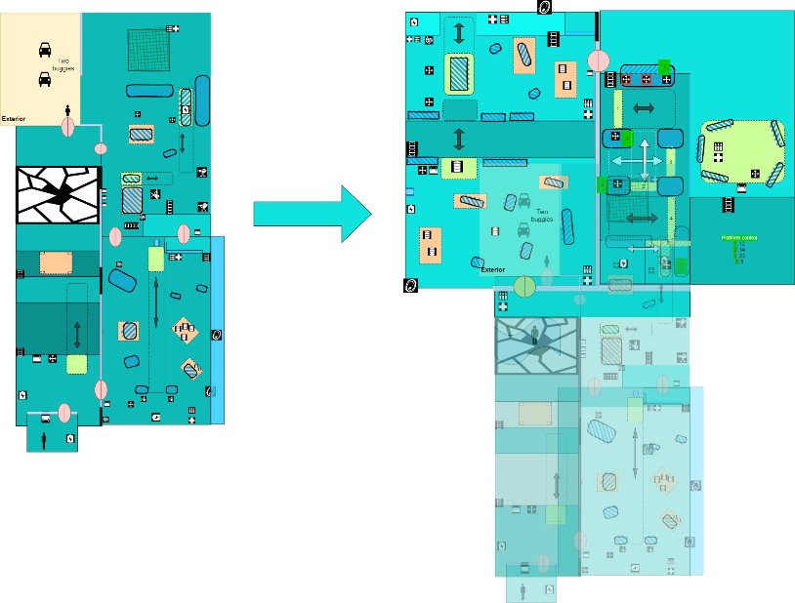

Figure : Top-down view of the map structure

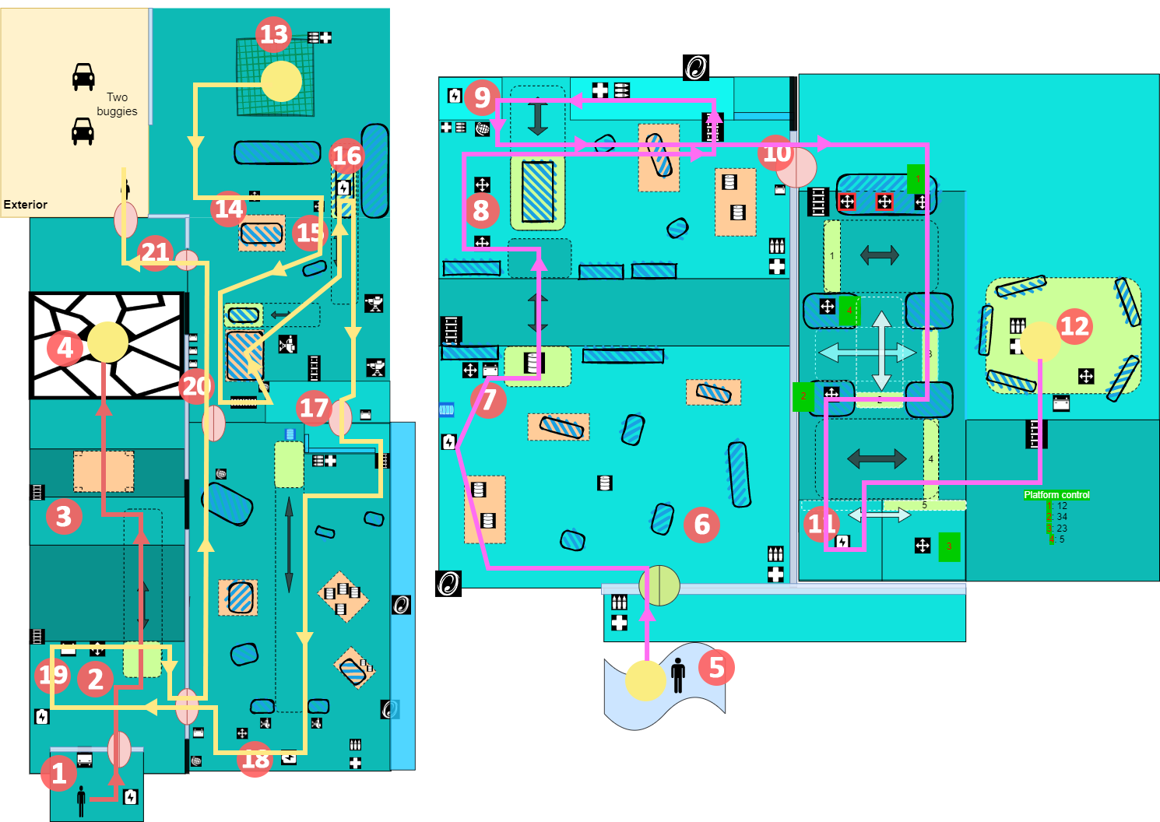

Figure : Top-level summary [11]

|  |  |
| --- | --- |
| Map Label | Top Level Gameplay Summary |
| 1-4 | * Gordon wakes up in the room and sees Alyx waving to him at the opposite door through the window. * From Alyx’s speaking, Gordon knows she is here to pick him up, so Gordon needs to meet with Alyx and escape with her * Gordon uses platforms (moving platform & hanging platform) to rush to Alyx * Before Gordon reaches her, the floor breaks and Gordon falls onto the lower floor (several floors lower) * Visual theme   + Starting room -> office theme   + First room -> warehouse |
| 5-7 | * After getting up from the water pool, Gordon sees an elevator in the right front room, he needs to get that elevator to send him back to the top floor * Gordon enters the left front room and encounters combine soldiers with SMG, he can use platforms (crush explosives) to kill them * After inserting the battery into the slot that activates the moving platform to send him to the opposite plane, Gordon encounters another group of combine soldiers from the opposite, he can use the moving platform to send explosives to them * Visual theme: factory |
| 8-10 | * Gordon needs to get the battery to enter the elevator room * Gordon encounters another wave of enemies from both the ground and the higher plane * After killing enemies, Gordon needs to get the battery (Label 9) by stepping through the moving platform and entering the elevator room * Visual theme: factory |
| 11 | * Gordon finds out he needs a battery to activate the elevator, where the battery is on the opposite (Label 11) platform. * Gordon uses two try-out buttons (temporary effect) and one permanent button in the first place to figure out how they control different platforms * Gordon solves the platform puzzle to get the battery and use it to activate the elevator. * Elevator starts raising * Visual theme:   + Containers in the goo   + Old metal gate |
| 12-13 | * Gordon encounters three waves of enemies in the process   + Three passing floors   + One wave on each floor   + Different composition of enemies   + Different directions of openings (where enemies attack from) * Gordon can choose to crouch instead of fighting and wait to be sent up   + Since enemies come from different directions, Gordon is forced to participate in part of the combat * After getting back to the top floor, Gordon sees Alyx waving to him again outside through the window, and from Alyx’s words, he understands he needs to exit through the door in front of him in this room that requires three batteries   + Gordon can only see one battery in this room, but he sees another door in this room that only requires one battery to unlock, so he guesses he could get the other two from the room behind * Visual theme:   + Elevator -> Old-school elevator   + Passing floors -> Jail blocks |
| 14-17 | * Gordon’s way to the battery and doors in this room is guarded by soldiers controlling mounted guns and two normal patrolling soldiers * Gordon uses moving platforms to block mounted guns and after killing normal soldiers he gets onto the higher platform, then he can use SMG grenades to kill the rest of the enemies (soldiers using mounted guns that are blocked) * Gordon grabs the battery on the opposite moving platform by forming the bridge with a hanging platform and a moving platform * Visual theme:   + Warehouse   + Containers |
| 18-19 | * Gordon enters the last room after inserting the battery and sees a door to the first room (the first battery), a battery in the opposite position * Gordon can use a moving platform to send explosives to enemies and kill them, or he can use grenades and normal cover shooting to clear the room * Gordon gets the battery from the first room and goes back, and he encounters a final wave of enemies rappelling down from above by breaking glass and the enemies coming from the ground spawning points * After killing them, Gordon uses the moving platform to help send him with two batteries back to the previous room * Visual theme:   + Warehouse   + Containers |
| 20-21 | * Gordon inserts all three batteries into the battery slots to unlock the door leading back to the first room   + Two from the last room [Label 18-19]   + One from the current room which was used to unlock the door to the last room * Gordon goes back to the first room (the opposite platform) and exits the building through the last door and reunites with Alyx outside * Gordon and Alyx now can escape together by driving buggies * Visual theme:   + Forest (trees & rocks)   + Highway   + Parking lot (gates, bricks, trashes, cars) |

### Higher floor - fall

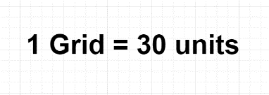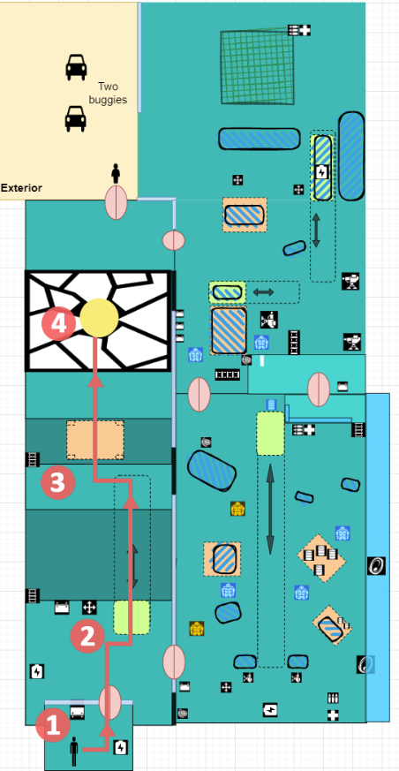

Figure : Higher floor - fall Walkthrough [11]

|  |  |  |  |  |  |
| --- | --- | --- | --- | --- | --- |
| Map Label | Event Summary | Event Details | Approx. Difficulty (1-10) | Approx. Time | Wow? |
| 1 | Wake up and exit the room | * The player sees Alyx calling out to him * Observe the environment, and find the door locked (challenge) * Find a battery and put it into the battery receptacle * Door activated, exit * **Challenge**: find the battery * **Goal**: give the player context and give the final goal; first tutorial to the battery | 1 | 0:30 |  |
| 2 | Activate the MP (moving platform) and use it to get onto the opposite platform | * Find pits blocking the way; a platform with the track is deactivated that requires a battery * Grab the battery near the battery slot * Insert it into the slot to activate the platform controller * Use the button to control the MP – walk on it after pressing the button before it moves   + Moving platform has two seconds delay before moving * The player can see the adjacent room on the right   + Lots of enemies   + Hanging platforms   + Arrow on the wall point up to the secret room above * **Challenge**: find a way and the battery * **Goal**: the first tutorial to the moving platform; reinforce battery | 2 | 0:50 | Y |
| 3 | Shoot the hanging platform to make it a bridge after falling | * Find a hanging platform above the pit * Shoot the hanging platform and it will fall to form a bridge spanning the gap between platforms * Cross the bridge * **Challenge**: find the way * **Goal**: first tutorial on the hanging platform | 2 | 1:10 |  |
| 4 | Get to Alyx, and “Critical Fall” | * Right before getting to Alyx, the door in front of the player suddenly shuts, and the floor beneath the player breaks * The player can see the adjacent room on the right   + Three battery slots   + Mounted guns   + Door to the previous adjacent room   + Battery on the moving platform   + Light on the elevator * **Challenge**: N/A * **Goal**: Give the first impression of the building structure; give the foreshadowing; reinforce the goal | 1 | 1:20 | Y |

### Lower floor

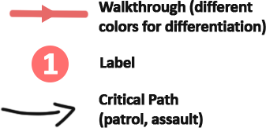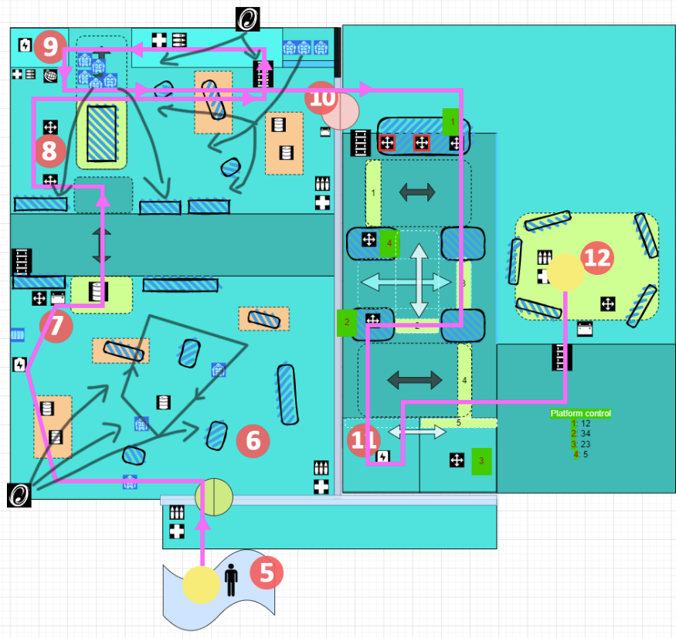

Figure : Lower floor Walkthrough [11]

|  |  |  |  |  |  |
| --- | --- | --- | --- | --- | --- |
| Map Label | Event Summary | Event Details | Approx. Difficulty (1-10) | Approx. Time | Wow? |
| 5 | Fall onto the lower floor | * Fall into a water pool * Get up onto the floor and gets pickups * See an elevator in the right front room   + And a light shining on the battery in the front behind the window * See three Combine soldiers patrolling in the left front room   + And a light shining on the door to the elevator room   + A light shining on the battery * Enter the left front room (through the sole door leading to the left room) * **Challenge**: N/A * **Goal**: Give the chance to observe the environment; give pickups and teach the player crates to stand for supplies | 1 | 1:30 | Y |
| 6 | First encounter with Combine soldiers | * Encounter 3 Combine soldiers with SMG * After killing them, another wave of combined soldiers with SMG (X3) comes out from the spawning point   + Use platforms (crush, explosives) to kill them   + Can shoot to get bigger covers * **Challenge**: Both waves push the player around, which forces the player to use cover and hanging platforms/explosives to help * **Goal**: introduce the enemies; teach the player to use mechanics in combat | 4 | 1:50 |  |
| 7 | The first ambush from the opposite platform | * See a goo blocking the way * Find a moving platform without a battery * Get the battery nearby and insert it into the slot * Five Combine soldiers with SMG come out behind the container from the opposite platform   + Can use a moving platform to send the explosives to them   + Can engage in the normal fight (several medium covers in the front), but harder since enemies get covers too * **Challenge**: Enemies get covers and they have five people lining up and aiming at the player together * **Goal**: teach the player to use the moving platform in combat | 5 | 3:00 | Y |
| 8 | Encounter another wave of enemies after getting to the opposite platform | * Take the moving platform to cross the gap * Another wave of enemies come out from both the ground (top right corner) and higher plane (spawning point)   + Use moving platform carrying containers as cover   + Can look down/crouch to see the movement of enemies   + Can shoot hanging platforms carrying blocks and explosives to kill enemies on the ground   + Can use the trigger to move the moving platform so that it’s at a better position as a cover to help the player fight against the enemies from above   + And the player now is safe to get SMG grenades and supplies at the top left corner   + Use grenades to kill enemies * The player can see an indicator sign around the moving platform that implies its moving direction * The player can see a button controlling the moving platform from [7] with sparks on it, the player can try it out and will learn it’s a broken button with a temporary effect (the platform will move forth and back continuously) * **Challenge**:   + Enemies from above limit the movement of the player – forcing the player to fight behind the cover   + Enemies from the ground push the player around however – this requires the player to prioritize and kill them using resources around as soon as possible * **Goal**:   + Reinforce the skill of utilizing covers, moving platform as cover, and hanging platform as a resource | 6 | 3:30 |  |
| 9 | Get the battery | * Get the battery on the top left corner of the room on the map * To cross the gap between higher platforms, the player needs to move the moving platform on the ground to form a bridge * **Challenge**: find a way to get the battery * **Goal**: reinforce the skill of using a moving platform to form away | 3 | 4:30 |  |
| 10 | Unlock the door and enter the puzzle room | * Use the battery to unlock the door * Enter the next room * **Challenge**: N/A * **Goal**: lead to the next path | 1 | 4:40 |  |
| 11 | Solve a moving platform puzzle to get the battery | * The player can see many buttons with different lights on them   + Six buttons with four lights in total     - Same lights indicate the same effect   + Two out of three buttons on the table are try-out buttons with sparks as an indication, with the last one a normal button   + Moving platforms have lights on them to indicate the corresponding buttons controlling them * Left try-out button on the table has the same effect as button 3, except it’s broken * Middle try-out button on the table has the same effect as button 2, except it’s broken * Button 4 controls gate 5, which moves horizontally * Control pattern:   + Button 1 -> platform 1&2   + Button 2 -> platform 3&4   + Button 3 -> platform 2&3   + Button 4 -> gate 5 * Solution: button 1 -> button 4 -> button 3 -> button 4 -> button 2 * **Challenge**:   + The player needs to use try-out buttons to plan their path to get the battery * **Goal**: combine the mechanics into a puzzle | 7 | 4:45 | Y |
| 12 | Activate the elevator and be ready to go back to the upper floor | * Insert the battery into the slot controlling the elevator controller * Press the button to activate * Gates close and the elevator starts rising * **Challenge**: N/A * **Goal**:   + draw attention   + imply the following event   + give rest and prepare for the next combat | 1 | 5:50 | Y |

### Elevator rising up

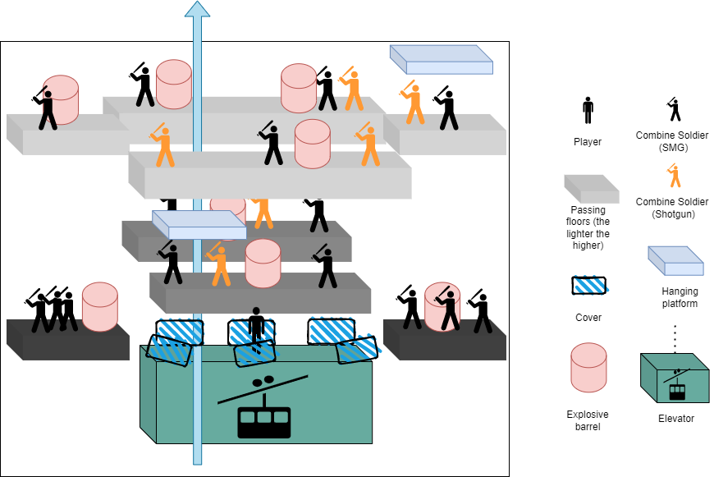

Figure : Elevator Walkthrough [11]

|  |  |  |  |  |  |
| --- | --- | --- | --- | --- | --- |
| Map Label | Event Summary | Event Details | Approx. Difficulty (1-10) | Approx. Time | Wow? |
| 12+ | Encounter three waves of enemies from three passing floors (each wave on each floor) on the elevator | * As the elevator rises, the player can gradually see enemies on each floor * Many covers on the edge of the elevator * The player can choose to crouch instead of fighting and wait to be sent to the destination – they don’t need to kill all enemies to progress   + However, enemies come from different directions which force the player to engage in part of the combat at least * Can use hanging platforms to crush or to get explosives, or shoot explosives on the ground to help in combat * Provide pickups (ammo and health) on the elevator * **Challenge**: require the player to locate enemies, resources quickly and take them down quickly and use covers effectively * **Goal**:   + reinforce the skill of locating useful items   + a fresh gameplay experience | 6 | 6:00 | Y |



### Text Description automatically generated with medium confidenceHigher floor - return

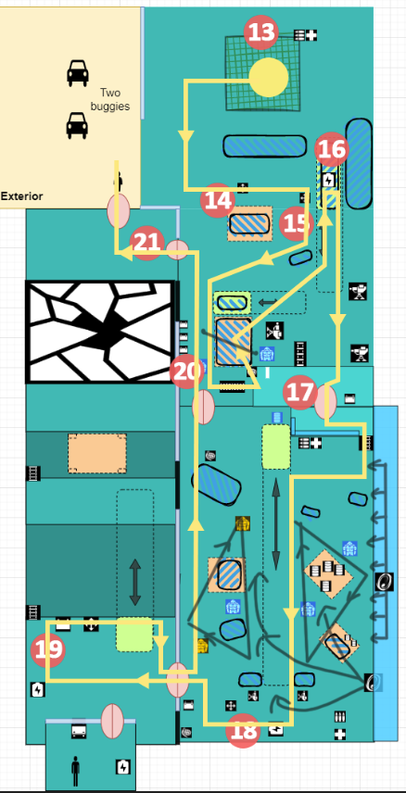

Figure : Higher floor return Walkthrough [11]

|  |  |  |  |  |  |
| --- | --- | --- | --- | --- | --- |
| Map Label | Event Summary | Event Details | Approx. Difficulty (1-10) | Approx. Time | Wow? |
| 13 | Get back to the top floor, see Alyx again | * Get back to the upper floor * Can see Alyx outside waving to the player through the window * Can see exterior scenes (forest, buggies, sky, etc.) * Alyx tells the player to get the door in this room to exit * The player sees there are three battery slots to unlock the door * The player sees another door with a light on it on the other side of the room * Can also see a battery on the left on the container (with a moving platform underneath) * Need to get the battery to enter the end room and collect the remaining batteries from that room to unlock the last door in this room * Can see indicator signs to indicate the moving direction of two moving platforms in front of the player * **Challenge**: observe the environment and make a plan * **Goal**:   + indicate the position of the final goal   + make plans | 1 | 6:30 |  |
| 14 | Get to the first button | * The player finds soldiers are controlling mounted guns guarding the area, they need to come up with a way to get through the space   + They will shoot the player if no cover which forces the player to think of a way   + The player could try to sprint through the space and get to the other side, but they will face     - Two soldiers patrolling around the ladder which prevents this, to some extent     - Battery is on the moving platform which requires the player to press the button to form a way by moving platforms * Moving platforms can be used to block their sightlines   + Sub-goal: they need to get the buttons first * Shoot the hanging platform to get a cover * The player now can safely press the button [near label 14]   + The moving platform (the one that moves horizontally) moves right to block the left mounted gun * Now the player can get to label [15] * **Challenge**: find the way by using platforms * **Goal**: reinforce the skill of utilizing platforms | 3 | 7:30 |  |
| 15 | Get the second button and platform to get through the space | * Press the second button (near [15])   + The moving platform (vertical one) moves down to block the right mounted gun * Walk to the door (bottom one) but encounters two patrolling soldiers with SMG halfway * After killing them, shoot the hanging platform under the horizontal moving platform to block the bottom right mounted gun * Get to the higher platform and use grenades provided there and kill all enemies that were blocked * **Challenge**:   + find the way by using platforms   + cover shooting * **Goal**: reinforce the skill of utilizing platforms | 6 | 7:50 | Y |
| 16 | Get the battery by forming a bridge | * Now the moving platforms and the hanging platform are used to form a bridge leading to the battery * If the player takes different strategies from the one mentioned above, they will need to figure out the way to get the battery * **Challenge**: find the way by using platforms * **Goal**: reinforce the skill of utilizing platforms | 3 | 8:20 |  |
| 17 | Enter the last room | * Insert the battery and unlock the door * Enter the next room | 1 | 8:30 |  |
| 18 | Clear the room and get the battery | * The player enters an elevated glass room * Can see enemies on the ground shooting at the player (blocked by the glass)   + Two soldiers controlling mounted guns on the other end side   + Six soldiers -> two with a shotgun, four with SMG * Can see a battery behind the mounted guns * Can see a moving platform carrying explosives generated by a generator and it runs to the mounted guns (guess from the track) * Can use the moving platform to send explosives to the enemies * Can use hanging platforms to crush enemies or get one-off explosives * Can use SMG grenades * After eliminating the existing enemies, another wave comes out from the spawning point (2 shotgun, 2 SMG)   + Fewer enemies make it possible for the player to jump down and take them down through a normal fight * Player could choose to engage in a normal fight, but walking out from the glass room (which is a safe cover) will cause the player to be targeted by all enemies which forces the player to use grenades/hanging platforms/moving platforms in the combat   + Moving platform is slow   + Hanging platform is a limited resource   + Normal fight will be efficient when dealing with fewer enemies but more dangerous * **Challenge**:   + find better strategies in a different situation   + cover shooting   + explosion shoot   + get resources from platforms   + switch weapons (or things that can be used to fight enemies such as grenades and explosives) * **Goal**: test skills of all that has been taught (platforms and resources) | 7 | 8:35 | Y |
| 19 | Get the battery from the first room | * Get the battery in this room * Insert it into the slot connected to the first room * Go back to the first room and take away the first battery * **Challenge**: puzzle-solving: find the last battery * **Goal**:   + reuse of space   + give a clearer view of the structure to help the player recognize | 2 | 9:35 |  |
| 20 | Encounter an ambush from above after returning | * Encounter an ambush both from above and the spawning point on the ground   + 8 soldiers (3 shotgun, 5 SMG) break the glass and rappel down to the room     - They have various delay time, so they won’t swarm into the room   + Two soldiers with SMG come out from the spawning point   + Before the ambush starts, lights above near the ambush room flash for 5 seconds as an indication and draw attention * Can use hanging platforms * Can use SMG grenades (provided in the bottom left corner) * Can take over the mounted gun to kill enemies   + This is efficient and powerful, but it will expose the player to the enemies since there’s no cover and enemies come from different points * Have many covers in the room, cover-shooting is reinforced * **Challenge**:   + different strategies in different situations * **Goal**:   + A fresh gameplay experiences   + Test all skills | 8 | 9:45 | Y |
| 20+ | Collect all three batteries | * After clearing the room throw two batteries onto the moving platform   + One from the first room   + One from the battery slot unlocking the door to the first room * Use it to send batteries and the player to the door leading to the previous room * Insert all three batteries into the slot and unlock the last door   + The last battery is in the battery slot that unlocked the door to the last room * To avoid long walking * **Challenge**: find a quicker way * **Goal**:   + test the skill in a simpler way   + last minute to rest and enjoy | 4 | 10:50 |  |
| 21 | Reunite with Alyx | * Open the door that was previously seen from the beginning * Get out and reunite with Alyx * See the beautiful exterior scene and breathe the air of freedom (forest, buggies, sky, etc.) * Level completed | 1 | 11:00 | Y |

## Skill Progression Chart

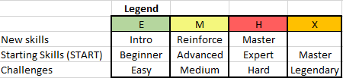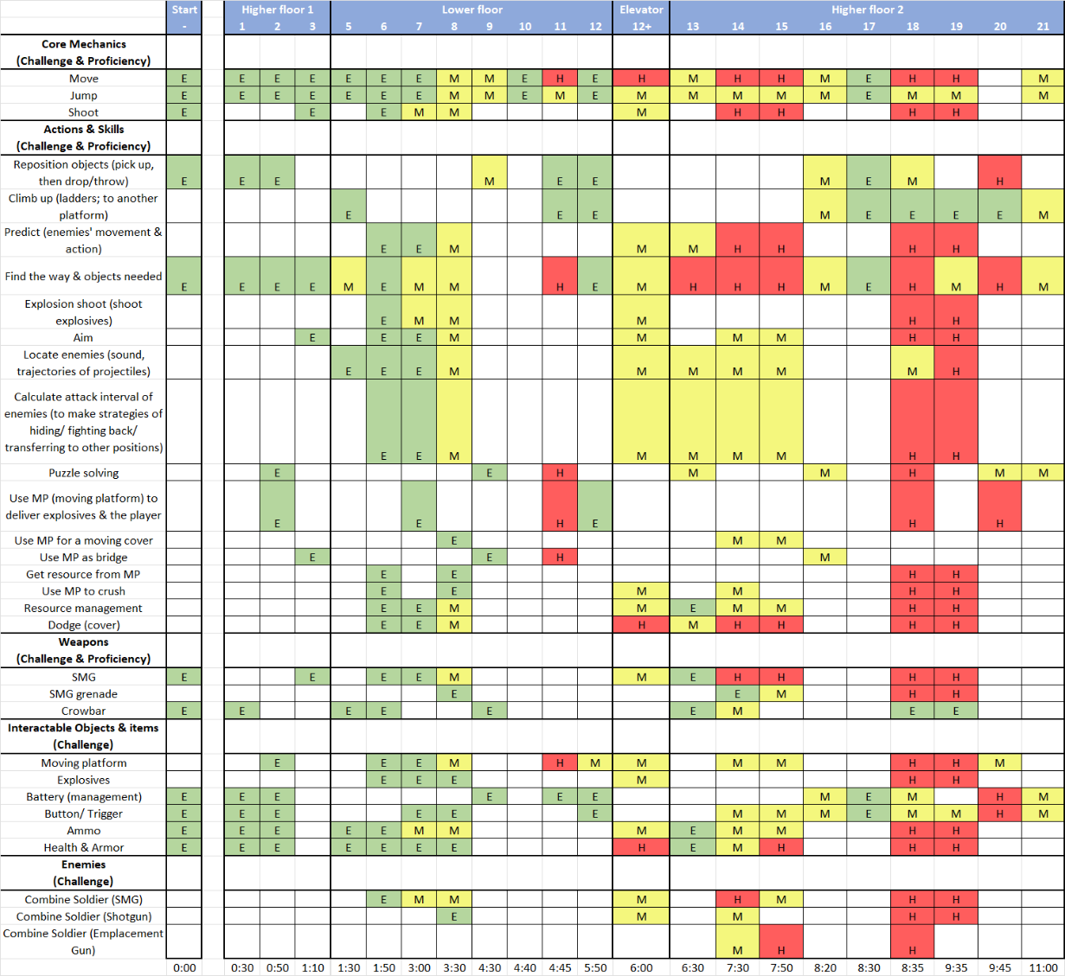

Figure : Skill Progression Chart

### New Skills/Gameplay Mechanics

* Platforms
  + Deliver (objects & the player)
    - Can send the player from one position to another position where a gap lies between
    - Can send the explosives to a position where enemies gather up, where the player cannot easily approach, and make an explosion shoot to help eliminate the foes
  + Crush
    - Shoot the hanging platforms to let them fall and crush enemies beneath
      * The player also needs to watch out for it since it could crush the player as well
  + Bridge
    - The platform hanging in the air can fall on the floor by shooting the connecting point that is tied with the platform, which will form a bridge allowing the player to walk on it
      * higher layer (between higher platforms)
      * cross the gap
  + Resource drop
    - Shoot to make the platform fall with some resources on it (explosives and covers)
  + Moving cover
    - Some platforms carry covers (containers etc.), they will move together
      * Use a controller to control their movement – create a moving cover
      * Could be used to block enemies as well
  + Could be used to form a bridge
  + Platform puzzle
    - Some platforms may be controlled by more than one button, and some buttons are try-out buttons – which have only a temporary effect, which require the player to find a correct path/order to trigger platforms to send the player to the destination
* Battery
  + Activate the controller
    - Some moving platform controllers require a battery to activate
  + Open the door
    - Same as above
  + Management
    - Reuse of batteries to solve a battery puzzle
* Explosives and SMG grenades
  + Combined use of explosives and platforms
    - Get explosives from a hanging platform
    - Send explosives using a moving platform
  + Combined use of explosives and grenades
    - Grenades could be used to ignite explosives if it’s dangerous to aim at enemies straight away
      * Using its parabolic trajectory, the player could attack the enemies behind the cover where it’s hard to hit the enemies with the grenade itself
  + Grenade is powerful, but as the player shoots down more covers, the area will become more cramped which limits the use of the grenade (since it’s easier to hurt the player itself if firing the grenade in a narrow area)
* Lure enemies
  + Lure enemies to the place where hanging platforms are above to get the platforms used in a more effective way
* Moving shooting/ cover shooting
  + Since there will be extra customized covers by shooting hanging platforms, the player will have more chance to move around the space using different covers
    - It also reinforces the player’s skill to create covers from platforms and utilize them, or to consider those “indirect” covers when making better strategies
  + Shooting with moving cover reinforces the skills of the move, aiming, hiding, and platform controlling
  + Elevator
    - Reinforce the skill of cover shooting (which requires rapid moving and finding safe points in a limited area while locating and utilizing resources at the same time)

## Hook(s)/Gameplay Highlights

* Using moving platforms in creative ways
  + Delivering objects & the player
    - Deliver explosives to enemies and shoot to blow them up
    - Deliver the player and batteries
  + A group of explosives drop from above and create a deadly fireworks show
* Using a moving platform to solve a puzzle
  + Control the movement of platforms to form a bridge (to get a battery)
  + Move MP in a specific order to send the player to the destination
    - When MPs are controlled by more than one buttons
* Fall & raise flow
  + The game starts with falling off the floor and finding a way back (to reunite with Alyx). Finally, the player will take an elevator to get back to the top floor where there is combat on the elevator when it is rising in the tunnel
* Enemies break into the battlefield by breaking glass and rappelling down

## Context

This level, serving as a parallel side-storyline that is not featured in the main story, takes place after the combat in Hallway 17 or Sand trap (before reaching Nova Prospekt ). Gordon is seized by Combine and thrown into the prison block. Though he was secretly transferred to an office by an undercover resistance soldier, he still needs to find a way to escape the building that’s under lockdown and reunite with Alyx. This level falls within the challenge curve of the base game after Hallway 17 and Sand trap so the player is assumed to have medium-level skills, however, since Gordon is thrown into jail, the weapon available to him is limited. To compensate for this, this level goes way deeper with the limited “weapons” (SMG, SMG grenade, crowbar, platforms) at a level raising from the medium by facing enemies with more and more powerful weapons (SMG -> Shotgun -> mounted gun) and more difficult terrains (more verticality and fewer covers)

### Backstory

On Gordon Freeman’s way to rescue Eli Vance, he got held up in an ambush of Combine soldiers, and finally, he failed. As a result, Gordon was taken back to Nova Prospekt and thrown into a prison block, soon enough he will be executed. Alyx heard about this by chance and decided to put the rescue mission under the highest priority. To do that, Alyx tasked an undercover soldier in Nova Prospekt to bring Gordon out of the facility. However, right after the soldier transfers Gordon, the missing is found and reported with lockdown activated. The soldier could only leave Gordon back in a provisional safe room and join the patrol. Now, it is Gordon’s task to take actions whatever he can to find a way out to meet with Alyx who has prepared buggies and been waiting outside for a while.

### Aftermath

Gordon Freeman is rescued and free again. But he never forgets about his top priority – find Eli Vance. Now he, together with Alyx, is ready to start his new journey and see this old friendly face.

## Development Schedule

|  |  |
| --- | --- |
| Milestone | Date |
| LDD | Oct 31, 2022 |
| Whitebox | Nov 7, 2022 |
| Initial Gameplay | Nov 14, 2022 |
| Gameplay Complete | Nov 21, 2022 |
| Aesthetics | Nov 28, 2022 |
| Launch | Dec 5, 2022 |

## Aesthetic References

Nova Prospekt takes the theme of “Prison”, which requires a sterile, depressive look to create the flavor. However, since Gordon’s stage is not in a real “prison block”, it doesn’t have to look the same as a jail (Gordon was moved to someone’s office or the storage). In this case, rooms should be more like an office (when Gordon’s still on a high floor), a warehouse, or a factory (when Gordon falls off). With the top of the forest or highway and parking lot outside the building. The lighting should be either fluorescent or bright, but both are clear enough on the higher floor and should get darker as the floors down.

### Visual Theme 1: Warehouse & factory & office & open area and layout

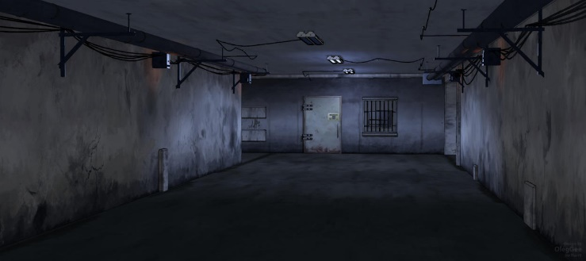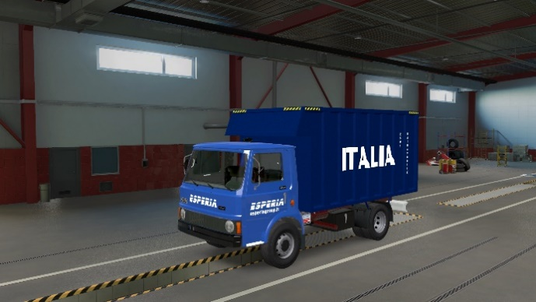

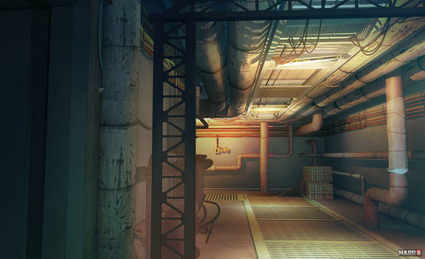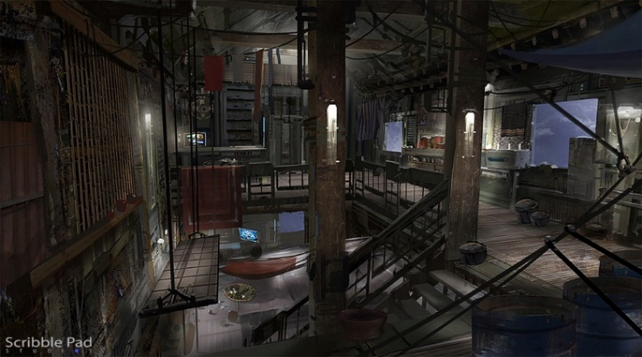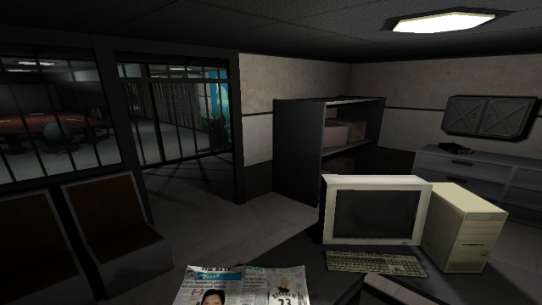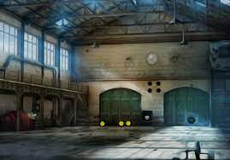

Figure : Contact Sheet for Visual Theme 1 [1 – 6]

### Visual Theme 2: Parking lot & forest & highway and layout

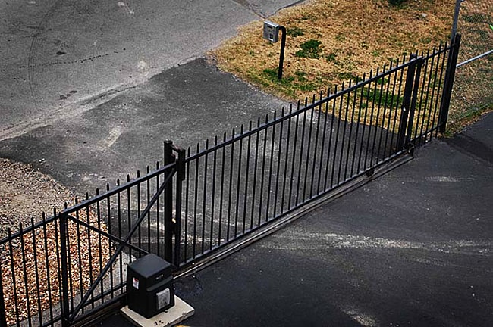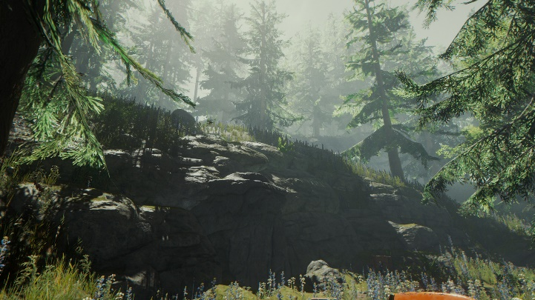

## Devastated Factory in the Mountains Stock Photo - Image of abandoned, outdoor: 31475356Unique Requirements and Risks

Figure : Contact Sheet for Visual Theme 2 [7 - 10]

|  |  |  |  |
| --- | --- | --- | --- |
| Map Label | Description | Type | Priority |
| 2, 7, 8, 11, 12, 14, 15, 16,18 | Moving platform – Crush, Bridge, Resource, Cover, Transfer   * Connected with a rope (if droppable, an extra breakable joint point is needed) * Movement can be controlled (horizontal, vertical) by buttons/ trigger | Script | High |
| 1, 2, 7, 9, 10, 11, 12, 16, 17, 19, 20 | Battery   * Can be placed into the battery jar automatically when getting close to it holding a battery * Should activate the trigger or door | Script | High |
| 6, 7, 8, 12, 14, 15, 18, 19 | Combine soldiers AI   * Ambush behind the cover * And know to use cover in general * In some scenarios, there will be an emplacement gun, and Combined soldiers should know to use * Spawn and assault (rappel down) * Should not drop the weapon when dead * Breaks glass and rappels down in the last wave | Script | High |
| 4 | Floor break | Script/ Mesh | High |
| 1, 13, 21 | * Alyx calls Gordon * Waves at him * Another wave * Ending animation | SFX/ Script | Medium |
| 1, 13, 21 | Text | Script | Medium |
| 4 | When getting close to the main door, the door is closed & locked | Script | High |

## Key Asset Needs

|  |  |  |
| --- | --- | --- |
| Description | Type | Priority |
| Combine Soldiers (SMG, shotgun, grenade) | Model | High |
| 5 Concrete Textures | Texture | High |
| Battery | Prop | High |
| Battery Receptacle | Mesh, Texture | High |
| Alyx | Model | High |
| Office Door | Mesh, Texture | High |
| Trigger/ Button (left & right, up & down) | Mesh, Texture | High |
| SMG | Weapon | High |
| Crowbar | Weapon | High |
| Explosive Barrel & Oil Drum | Prop | High |
| Metal Platform | Mesh, Texture | High |
| SMG Grenade | Weapon | High |
| HEV Suit | VFX, HUD | High |
| Health Dispenser | Prop | High |
| Pickups (SMG Ammo, Grenade, Health) | Prop | High |
| HEV Dispenser | Prop | High |
| Covers (containers, other props) (Interior, warehouse, factory) | Prop, Mesh, Texture | High |
| Elevator | Prop, Mesh, Texture | High |
| Skybox texture (daytime or dusk [better]) | Texture | High |
| Rope | Prop | High |
| Emplacement Gun | Weapon | High |
| Metal Ladder | Prop | High |
| Glass | Texture | High |
| Combine Shield | Prop | High |
| Ceiling Hanging Light (Bulb; Fluorescent, bright, natural) | Prop/ VFX | High |
| Indicator Lamp (Green, Red, yellow, purple, blue, white) | Prop/ VFX | High |
| Skybox texture (daytime or dusk [better]) | Texture | High |
| Sparks and smokes (indication used for buttons) | VFX | Medium |
| Floor with stains (Interior; Exterior) | Mesh, Texture, Decal | Medium |
| Panel Desk (Interior, office) | Prop | Medium |
| Warehouse Door (Interior, warehouse) | Prop | Medium |
| Warehouse Crate (wooden, metal) (Interior, warehouse) | Prop | Medium |
| Office Computer (Interior, office) | Prop | Medium |
| Office Desk (Interior, office) | Prop | Medium |
| Office Shelves (Interior, office) | Prop | Medium |
| Office Lockers (Interior, office) | Prop | Medium |
| Office monitors (Interior, office) | Prop | Medium |
| Buggies (Exterior, parking lot) | Prop | Medium |
| Debris (Interior; Exterior) | Prop | Low |
| Rails (Interior, factory) | Prop | Low |
| Warehouse Dirt (Interior, warehouse) | Texture | Low |
| Peeled Paint (Interior, factory; Exterior, parking lot) | Decal | Low |
| Tire Tracks/ Bloodstains (Exterior, highway, parking lot) | Decal | Low |
| Posters (Interior, warehouse; Exterior, parking lot) | Decal | Low |
| Gates (Exterior, parking lot) | Prop | Low |
| Rocks (Exterior, forest, highway) | Prop | Low |
| Trash (Exterior, parking lot, forest) | Decal | Low |
| Trees (Exterior, forest) | Prop | Low |
| Alyx calls to Gordon (beginning, middle, and end) | Audio | Low |
| Moving sound of moving platforms | Audio | Low |

# References

[Cover Image] “Elevator shaft - now with electrified water! image - hazardous course: Source mod for half-life 2,” Mod DB. [Online]. Available: <https://www.moddb.com/mods/hazardous-course-source/images/image-3>. [Accessed: 29-Oct-2022].

[1] “Explore the best Narr8 Art,” DeviantArt. [Online]. Available: <https://www.deviantart.com/tag/narr8?page=4>. [Accessed: 29-Oct-2022].

[2] “Office Space Level Design Image - Noise,” Mod DB. [Online]. Available: <https://www.moddb.com/games/noise/images/office-space-level-design>. [Accessed: 29-Oct-2022].

[3] “Explore the best Narr8 Art,” DeviantArt. [Online]. Available: <https://www.deviantart.com/tag/narr8>. [Accessed: 29-Oct-2022].

[4] “Board index,” Fiat 50 NC v.1.44. [Online]. Available: <https://forum.scssoft.com/viewtopic.php?t=303683>. [Accessed: 29-Oct-2022].

[5] Iren, “Abandoned Warehouse Fun Escape,” Escape Fan, 18-Aug-2020. [Online]. Available: <https://escapefan.com/abandoned-warehouse-fun-escape/>. [Accessed: 29-Oct-2022].

[6] “Titanfall concept art - interior by James Pack: Sci-Fi: 2D: Cgsociety: Environment concept art, concept art, titanfall,” Pinterest, 09-Jun-2015. [Online]. Available: <https://www.pinterest.com/pin/311452130457265304/>. [Accessed: 06-Dec-2022].

[7] “The forest on Steam,” Welcome to Steam. [Online]. Available: <https://store.steampowered.com/agecheck/app/242760/>. [Accessed: 06-Dec-2022].

[8] N. Y. G. Staff, “Own a parking lot? 5 reasons you need security gates,” nygates, 29-Aug-2016. [Online]. Available: <https://www.nygates.com/own-a-parking-lot-5-reasons-you-need-security-gates/>. [Accessed: 06-Dec-2022].

[9] “Highway photos, Download Free Highway Stock Photos &amp; HD Images - Pexels.” [Online]. Available: <https://www.pexels.com/search/highway/>. [Accessed: 07-Dec-2022].

[10] Mangojuicy, “Devastated factory in the mountains stock photo - image of abandoned, outdoor: 31475356,” Dreamstime. [Online]. Available: <https://www.dreamstime.com/royalty-free-stock-image-devastated-factory-mountains-desolated-ruined-anthracite-open-mine-dechtarka-slovakia-image31475356>. [Accessed: 06-Dec-2022].

[11] Layne Zhang, created using Diagram.io & Photoshop, Oct 30, 2022

[12] “Already 4122 free icons for your games,” Game. [Online]. Available: <https://game-icons.net/>. [Accessed: 30-Oct-2022].