

LIT 2: Time Motion

Version 1.0

|  |  |
| --- | --- |
| Designer: | Layne Zhang |
| Document Date: | 3/22/2023 |
| Intended Level Delivery Date: | 5/9/2023 |

**Document Revisions Table**

|  |  |  |  |
| --- | --- | --- | --- |
| **Version** | **Description** | **Requestor** | **Date** |
| 1.0 | Initial Document | Professor Brandon Stephens | 3/9/2023 |
|  |  |  |  |
|  |  |  |  |
|  |  |  |  |
|  |  |  |  |

# Table of Contents

Table of Contents 2

Table of Figures 3

Level Information 4

Quick Summary 4

New Skills/Gameplay Mechanics 5

Planned “New” Mechanic 5

Puzzle Design and Mechanics 6

Level Map(s) 7

Overview Map 7

Room 1 8

Room 2 11

Room 3 – 1 (continued next section) 13

Room 3 - 2 16

Development Schedule 18

References 19

# Table of Figures

Figure 1: Overview Map [1] 7

Figure 2: Room 1 Layout [1] 8

Figure 3: Room 2 Layout [1] 11

Figure 4: Room 3 Layout 1 [1] 13

Figure 5: Room 3 Layout 2 [1] 16

Level Design Document

# Level Information

## Quick Summary

This level features using three different types of tiles, and cubes to solve puzzles by sending the cube to the corresponding pressure plate to help collect color keys and thus unlocking the door, where the red tile controls horizontal movement (cube only), the blue tile controls vertical movement (cube & player) and the green tile controls cube’s position at different times.

The level should be finished in 6 – 12 minutes.

(Note: This level builds on the mechanics from the last level which features color keys & boosted jump)

## New Skills/Gameplay Mechanics

### Planned “New” Mechanic

|  |  |  |
| --- | --- | --- |
| Mechanics | Description | Implementation |
| Red tile | * Has arrow on the tile indicating the movement direction * Give the cube an impulse to the direction according to the tile’s arrow * Press R to rotate the tile (and its direction) when standing close to the tile | * Rotate: check if triggered -> inside the trigger box 1 -> get key “R” -> set new rotation (previous rotation + 90 degree) * Cube movement: event tick -> check if triggered -> get self rotation -> get self forward vector X speed (delta position) -> for each loop -> add actor world offset to overlapping actors (cube, delta position) |
| Blue tile | * Give the cube & the player an upward impulse | * On overlap -> check if triggered -> cast to cube/player -> add upward impulse |
| Green tile | * When standing on the green tile and holding the cube, press F to record the current position. Then whenever the player presses F again, the cube will be reversed to its recorded position * Has arrow on the tile indicating the movement direction * Can give the cube an impulse to the direction indicated by the arrow on this tile (this is to make sure the cube can be passed to the next tile after teleporting) | * Record: on overlap -> check if triggered -> check if holding the cube -> get key F -> record the actor (cube) -> record the current position vector * Reverse: Get key F -> if already recorded -> set cube location (recorded vector) * Cube movement: same as red tile |
| Plate (tiles) | * When the cube or the player stands on the plate, the corresponding tiles light up and are available to use | * Plate: On overlap -> cast to cube/player -> set triggered (bool) -> set tile material (dark -> light) |

### Puzzle Design and Mechanics

Note: This part discusses the intended use of the mechanics mentioned above

|  |  |  |
| --- | --- | --- |
| Puzzle Design | Description | Execution |
| Planned path (normal use) | * Collect cubes, activate trigger, and adjust the direction of tiles to deliver the cube | * Cubes * Tile triggers (plates) * (Some permanent tiles, which exist in the room not controlled by a trigger, and their colors cannot be switched) |
| Reverse to get the cube back | * Record the position of the cube at position A, and send the cube to a higher platform B using red & blue tiles (these tiles, and the gate on another higher platform C, are activated when the player stays at A), when the cube hits the plate on B, unlocks the blue tiles to C, when the player gets to the gate on C, reverse the cube to hit A, gate opens | * Cube * Plate X 2 (one unlocks blue tile to C, one unlocks door & tiles to B) * Some common/permanent tiles to reduce the difficulty and give some hints |
| Remote control | * The player stays on a higher platform A and needs to get the cube on lower floor B. The player stands on the plate 1 on the platform A to change the tiles beneath the cube to make it move to the player (red tiles activated), and then the player stands on the plate 2 on the platform A to change the end tiles of the cube’s route to blue and make the cube bounce up to the player | * Plate X 2 (one to activate red tiles, one to activate blue tiles) * Higher platform * Cube |
| Reuse of cube & remote control | * Player places the cube on plate A and get the player onto the higher platform (blue tile), then reverse the cube and make it go into a different route following the preset tiles and unlock the door by hitting plate B for the player | * Plate 1 & 2: allow the player to leap onto the higher platform using blue tile (need cube) * Green tile: allow the player to teleport the cube back to follow the route set by trigger 1 * Plate 3: the end of the route set by trigger 1, can open the door |
| Combination of boosted jump & jump pad | * With the help of blue tile & double jump, the player can reach higher & farther platform | * N/A |

## Level Map(s)

### Overview Map

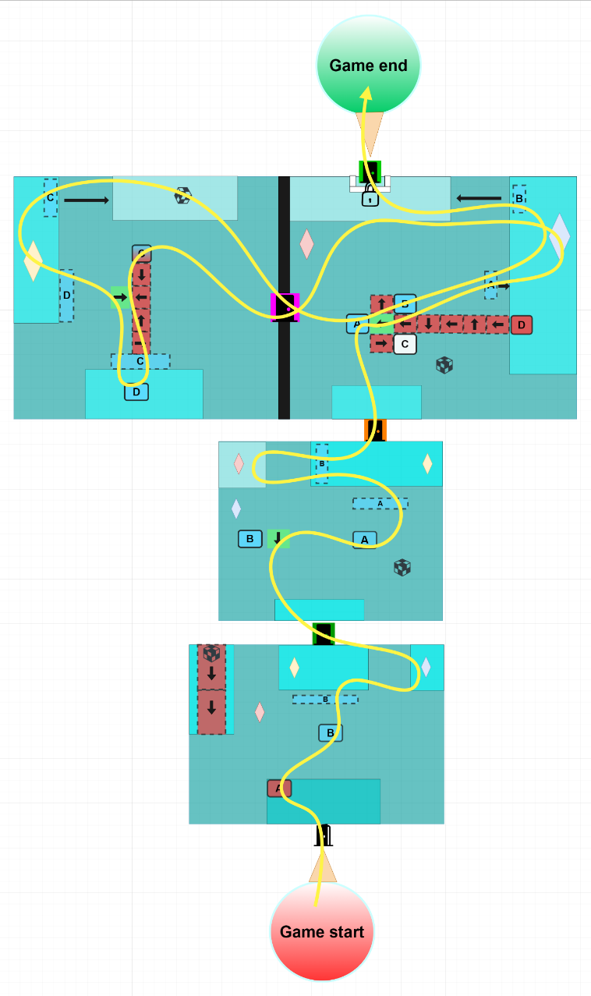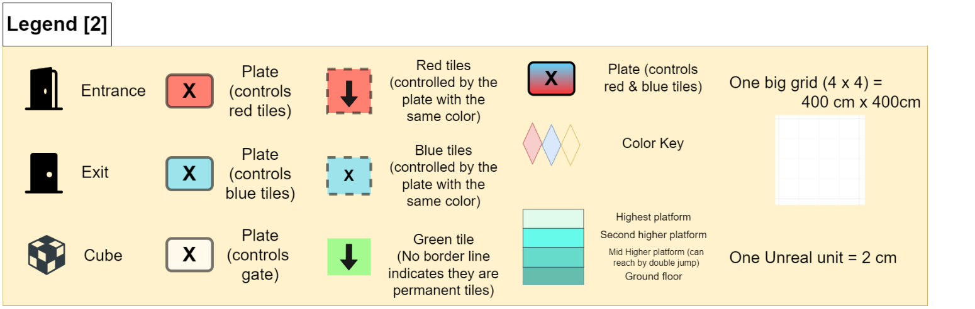

Figure 1: Overview Map [1]

### Room 1

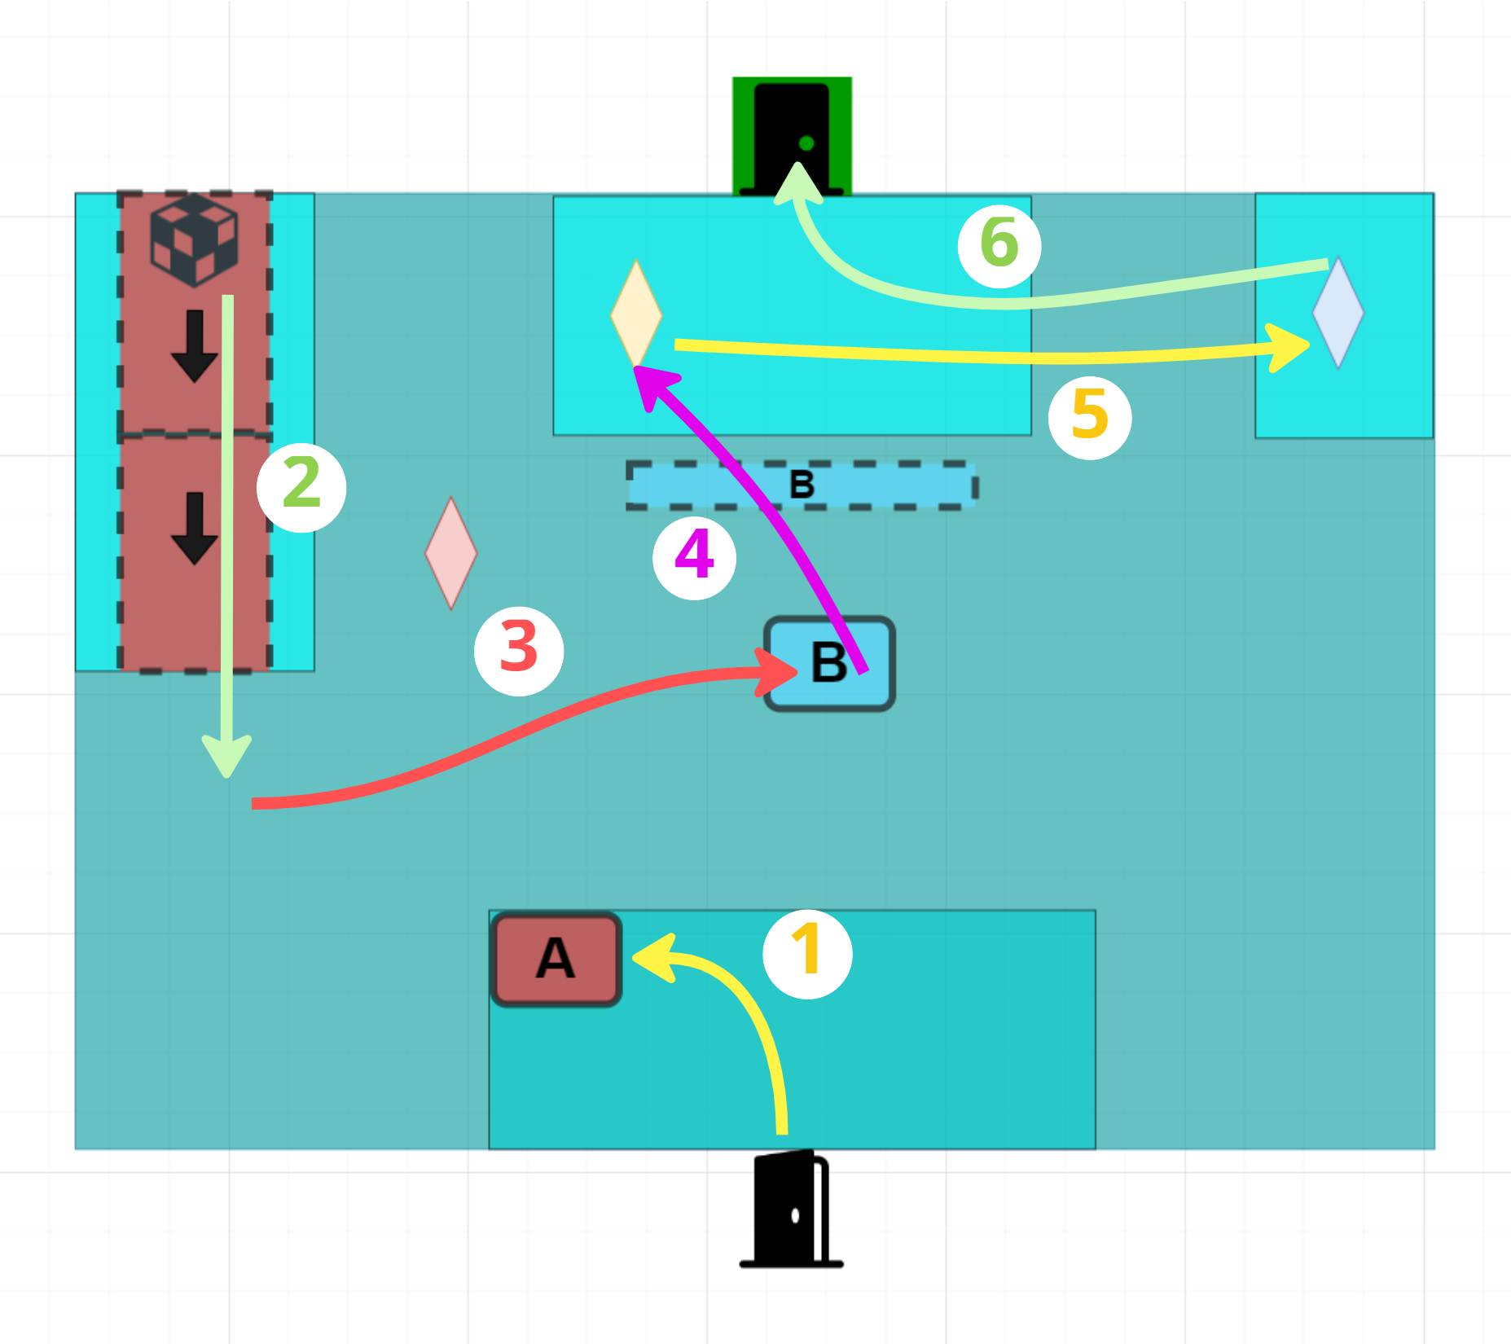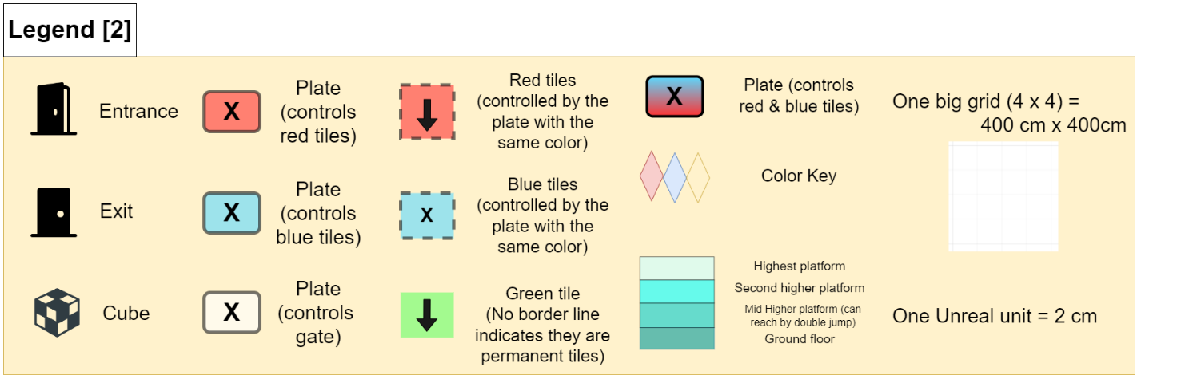

Figure 2: Room 1 Layout [1]

|  |  |  |  |  |  |
| --- | --- | --- | --- | --- | --- |
| Map Label | Event Summary | Event Details | Approx. Difficulty (1-10) | Approx. Time | Wow? |
| 1 | Observe and stand on plate A | Stand on plate A and see the red tiles on the higher platform become bright   * Goal:   + Learn the plate is triggered by pressure   + Learn the red tiles can be controlled by plate | 1 | 0:00 |  |
| 2 | See a cube is delivered to the ground | When standing on the plate A, see the cube on red tiles start to move forward and finally drop to the ground   * Goal:   + Learn the red tiles can deliver the cube * Conveyance:   + “Press E to pick up the cube, and press E again to drop”   + Colored plate indicates its controlling tiles | 1 | 0:10 | Y |
| 3 | Put the cube on plate B | Grab the cube from the ground and put it on plate B, see blue tiles light up   * Goal:   + Learn that cube can trigger the plate as well   + Learn the blue tiles can be controlled by plate | 1 | 0:20 |  |
| 4 | Use blue tiles to get to the higher platform, get yellow key | Walk to the blue tiles and get bounced to the higher platform. See the green door, collect the yellow key nearby   * Goal:   + Learn the blue tiles can push the player upward   + Reinforce the mechanic from level 1 | 2 | 0:35 | Y |
| 5 | Get onto the platform on the right and collect blue key | Use double jump to get onto the platform on the right, and collect the blue key   * Goal:   + Reinforce the mechanic from level 1 | 2 | 0:45 |  |
| 6 | Exit | Now the player has a green key, exit through the door | 2 | 1:00 |  |

### Room 2

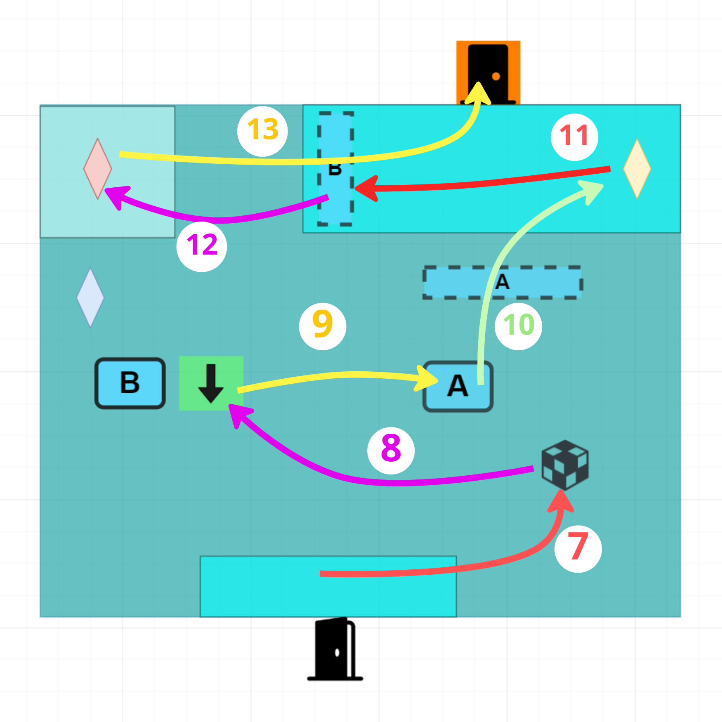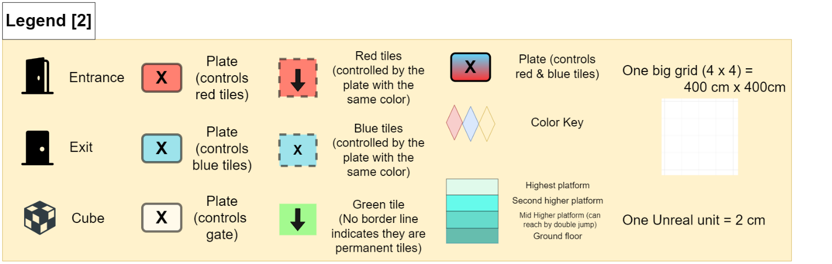

Figure 3: Room 2 Layout [1]

|  |  |  |  |  |  |
| --- | --- | --- | --- | --- | --- |
| Map Label | Event Description | Key Info (e.g. Challenges, Actions) | Approx. Difficulty (1-10) | Approx. Time | Wow? |
| 7 | Grab the cube | Observe the environment and grab the cube | 1 | 1:10 |  |
| 8 | Record the position | Record the position while standing on the green tile and holding the cube, adjust the direction of the green tile for future use (to left)   * Goal:   + Learn that green tile can record the position and teleport cube to the recorded position later   + Learn that green tile can push the cube to its indicating direction   + Learn that the player can rotate some tiles to change its direction * Conveyance:   + “Press R to rotate the tile”   + “Press F to record the position of the cube you hold, press F again to reverse its position” | 3 | 1:20 |  |
| 9 | Put the cube on plate A | Put the cube on plate A, see blue tiles are triggered | 1 | 1:35 |  |
| 10 | Get onto the higher platform & collect yellow key | Get onto the higher platform by blue tiles activated by plate A, find the orange door locked, collect the yellow key | 2 | 1:45 |  |
| 11 | Reverse the time of the cube | Press F to reverse the time of the cube and teleport it to the green tile | 3 | 2:10 | Y |
| 12 | The cube hits plate B and activates the blue tiles, use them to get red key | Then the green tile will push it to plate B and activate the blue tiles. Use blue tiles & double jump to jump onto the higher platform and get the red key   * Goal:   + Learn how to use “reverse” mechanic | 2 | 2:30 |  |
| 13 | Exit | Now the player has an orange key, exit through the door | 2 | 2:50 |  |

### Room 3 – 1 (continued next section)

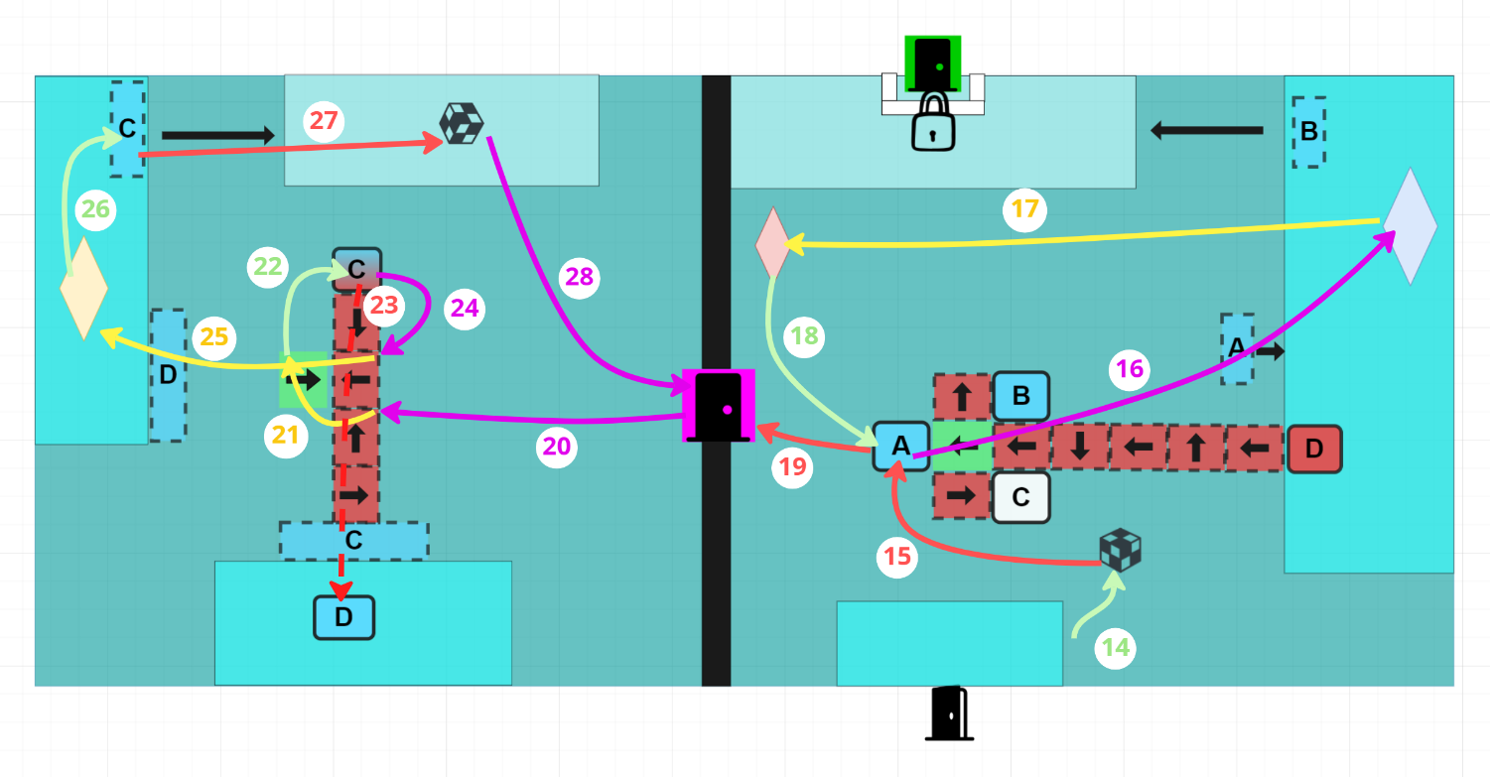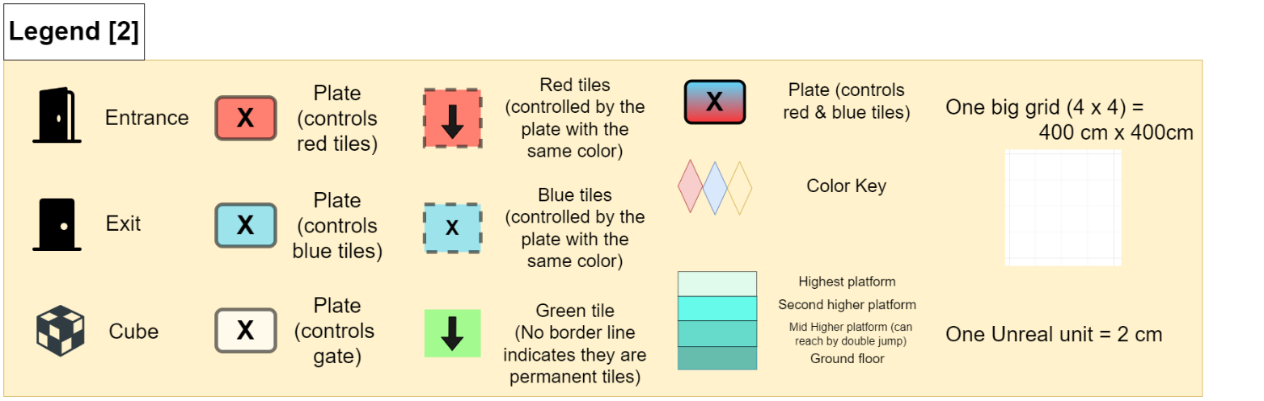

Figure 4: Room 3 Layout 1 [1]

|  |  |  |  |  |  |
| --- | --- | --- | --- | --- | --- |
| Map Label | Event Description | Key Info (e.g. Challenges, Actions) | Approx. Difficulty (1-10) | Approx. Time | Wow? |
| 14 | Grab the cube | Observe the environment and grab the cube | 1 | 3:00 |  |
| 15 | Put the cube on plate A | Put the cube on plate A and see blue tiles are activated | 2 | 3:10 |  |
| 16 | Get the blue key on the higher platform | Get the blue key on the higher platform with the help of blue tiles   * The player can use green tiles to activate B while standing on the higher platform and get onto the door’s platform, but they will finally realize they need the second cube to unlock the gate in front of the door and yellow key to forge a green key, but they can open the purple door at this stage | 2 | 3:25 |  |
| 17 | Get the red key | Collect the red key on the ground floor, now the player has a purple key | 1 | 3:40 |  |
| 18 | Take the cube from plate A | Take the cube from plate A (which will be used in the left room) | 2 | 3:50 |  |
| 19 | Go to the left room | Go to the left room through the purple door (now the player should have a purple key to unlock the purple door) | 2 | 4:05 |  |
| 20 | Adjust the red tiles to make them point to plate C | Observe the room and make the plan. Adjust the red tiles to make them able to deliver the cube to blue tiles C from plate C | 4 | 4:15 |  |
| 21 | Record the position of the cube | Stand on the green tile while holding the cube from the last room, record the position of the cube (keep the green tile facing right) | 4 | 4:35 |  |
| 22 | Stand on the plate C | Stand on the plate C, and see both red tiles from plate C to blue tiles C and blue tiles C themselves are activated   * There are two sets of blue tiles C controlled by plate C, the other one is on the higher platform | 1 | 4:55 | Y |
| 23 | Put the cube on the red tile in front of the player, send it to plate D | Put the cube on the red tile in front of the player, and see red tiles send it to blue tiles C, which will bounce the cube up on the higher platform and hit the plate D, the blue tiles D are activated | 4 | 5:00 | Y |
| 24 | Adjust the red tiles | Adjust the first two red tiles from top to make them point up (should be able to deliver the cube from the green tile to the plate C) | 6 | 5:25 |  |
| 25 | Get onto the higher platform | Get onto the higher platform through blue tiles D, and collect the yellow key | 3 | 5:50 |  |
| 26 | Reverse the cube and activate the blue tiles C | Reverse the cube and it will be delivered to the plate C through the green tile and two top red tiles (whose directions are adjusted in step 24) | 5 | 6:10 | Y |
| 27 | Get the cube | Use blue tiles C and double jump to get onto the other higher platform and grab the second cube | 4 | 6:45 |  |
| 28 | Take both cubes back to the right room | Take both cubes back to the right room | 2 | 7:05 |  |

### Room 3 - 2

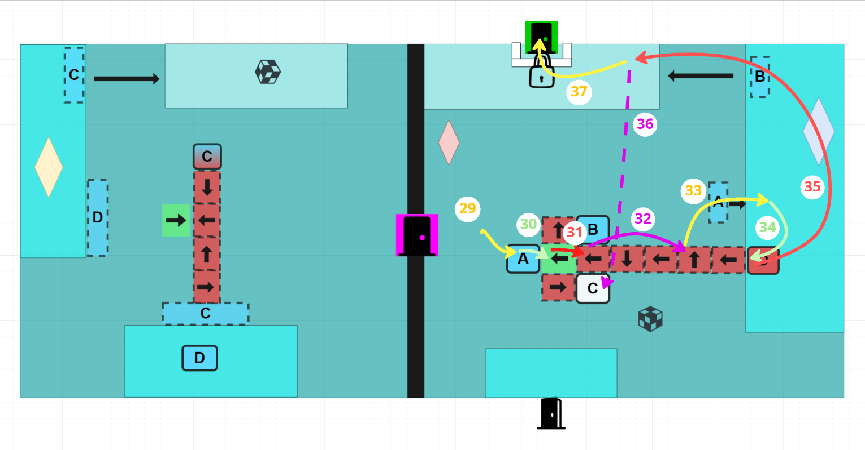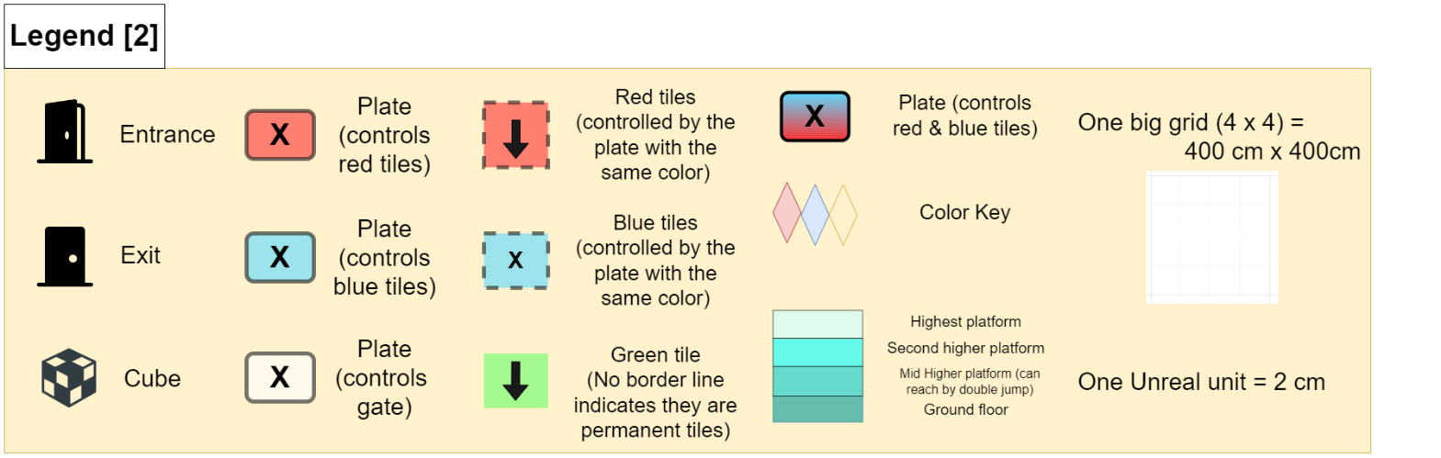

Figure 5: Room 3 Layout 2 [1]

|  |  |  |  |  |  |
| --- | --- | --- | --- | --- | --- |
| Map Label | Event Description | Key Info (e.g. Challenges, Actions) | Approx. Difficulty (1-10) | Approx. Time | Wow? |
| 29 | Put one cube on the plate A | Put one cube on the plate A and see blue tiles A are activated | 1 | 7:20 |  |
| 30 | Record the position | Record the position while standing on the green tile and holding the cube, adjust the direction of the green tile for future use (to down) | 7 | 7:30 |  |
| 31 | Pre-set the direction of one red tile | Pre-set the direction of the red tile which is between the plate B and the plate C (to up) | 8 | 8:00 |  |
| 32 | Pre-set the direction of the other red tiles on the right | Pre-set the direction of the other red tiles on the right of the tile talked in step 31, to make them all point to left | 6 | 8:40 |  |
| 33 | Get onto the higher platform | Get onto the higher platform through the blue tiles A (activated in step 29) | 3 | 9:00 |  |
| 34 | Stand on the plate D, and drop the cube onto red tiles | Stand on the plate D and activate the red tiles downside. Then drop the cube onto red tiles and see it being delivered to the plate B (red tiles are pre-set), then the blue tiles B are activated | 6 | 9:15 | Y |
| 35 | Get the blue key and get onto the higher platform | Get the blue key and use blue tiles B & double jump to get onto the higher platform where the green door lies on | 5 | 9:40 |  |
| 36 | Reverse the cube | Reverse the cube and see it hits the plate C (the direction of the green tile & the red tile have been pre-set properly), the gate unlocks | 9 | 10:00 | Y |
| 37 | Exit | Exit through the green door (now the player should have already collected both the yellow key & the blue key) | 2 | 10:50 |  |

## Development Schedule

|  |  |
| --- | --- |
| Milestone | Date |
| LDD | 3.23.2023 |
| Whitebox | 3.30.2023 |
| Initial Gameplay | 4.13.2023 |
| Gameplay Complete | 4.20.2023 |
| Aesthetics | 4.27.2023 |
| Launch | 5.9.2023 |

# References

[Cover Image]

2019 Aakash Jhaveri March 14, “Scientists were able to reverse time, but there's a catch,” Mashable India, 14-Mar-2019. [Online]. Available: <https://in.mashable.com/science/2545/scientists-were-able-to-reverse-time-but-theres-a-catch>. [Accessed: 15-Mar-2023].

[1] Zhang, Layne, diagrams made in draw.io, edited in Miro Board, Mar 21, 2023

[2] Iconfinder, “Free 1,504 lock icons,” Iconfinder. [Online]. Available: <https://www.iconfinder.com/search?q=lock&amp;=&amp;price=free>. [Accessed: 16-Mar-2023].