

Figure 1: [Cover Image]

*LIT 2*: “Pendulum Pandemonium”

Version 1.0

|  |  |
| --- | --- |
| Designer: | Jaye Williams |
| Document Date: | March 23, 2023 |
| Intended Level Delivery Date: | May 9, 2023 |

**Document Revisions Table**

|  |  |  |  |
| --- | --- | --- | --- |
| **Version** | **Description** | **Requestor** | **Date** |
| 1.0 | Initial Document | Professor Stephens | 3/23/2023 |
|  |  |  |  |
|  |  |  |  |
|  |  |  |  |
|  |  |  |  |

# Table of Contents

Table of Contents 2

Table of Figures 3

Level Information 4

Quick Summary 4

Level Map(s) 5

Overview Map 5

Room 1 Puzzle Map 6

Room 2 Puzzle Map 7

Room 3 Puzzle Map 8

Room 4 Puzzle Map (Part 1) 9

Room 4 Puzzle Map (Part 2) 10

Room 5 Puzzle Map (Part 1) 11

Room 5 Puzzle Map (Part 2) 12

Room 6 Puzzle Map 13

Objective(s) 14

Hook(s)/Gameplay Highlights 14

Skill Progression Chart 14

New Skills/Gameplay Mechanics 14

Context (N/A) 16

Backstory (N/A) 16

Aftermath (N/A) 16

Development Schedule 16

Aesthetic References (N/A) 17

<Visual Theme 1 (replace with meaningful name of theme)> (N/A) 17

<Visual Theme 2 (replace with meaningful name of theme)> (N/A) 18

Requirements (N/A) 19

Key Asset Needs (N/A) 19

References 20

# Table of Figures

Figure 1: [Cover Image] 1

Figure 2: Overview Map [1] 5

Figure 3: Room 1 Puzzle Map [2] 6

Figure 4: Room 2 Puzzle Map [2] 7

Figure 5: Room 3 Puzzle Map [2] 8

Figure 6: Room 4 Puzzle Map [2] 9

Figure 7: Room 4 Puzzle Map [2] 10

Figure 8: Room 5 Puzzle Map [2] 11

Figure 9: Room 5 Puzzle Map [2] 12

Figure 10: Room 6 Puzzle Map [2] 13

[Figure 6: Contact Sheet for Visual Theme 1 (N/A) 17](https://smu365-my.sharepoint.com/personal/jayew_smu_edu/Documents/WilliamsJ_LIT_LDD.docx#_Toc130471852)

[Figure 7: Contact Sheet for Visual Theme 2 (N/A) 18](https://smu365-my.sharepoint.com/personal/jayew_smu_edu/Documents/WilliamsJ_LIT_LDD.docx#_Toc130471853)

Level Design Document

# Level Information

## Quick Summary

Players work their way through a series of 6 rooms with pendulum-focused puzzles. To solve the puzzles, players change the direction of and turn on and off pendulums.

## Level Map(s)

### Overview Map

One Square = 250 cm

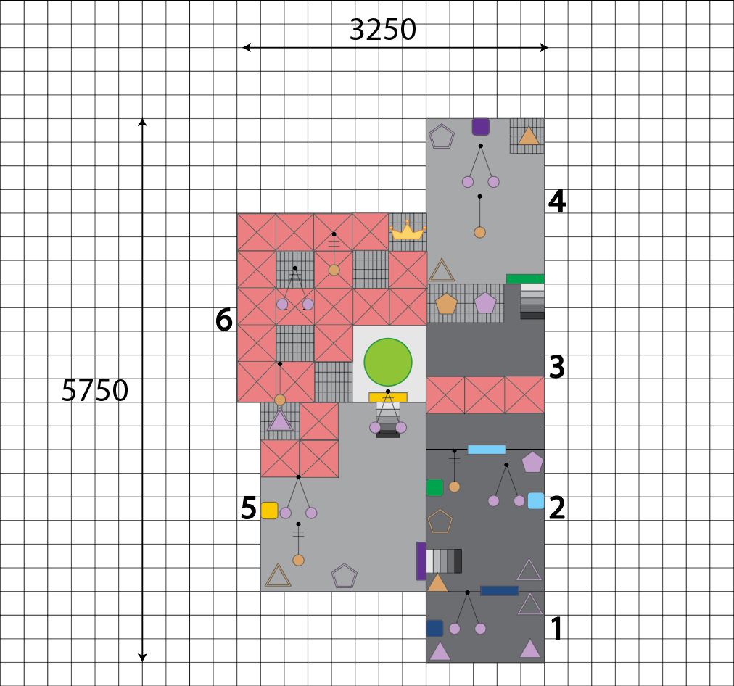

Figure 2: Overview Map [1]

|  |  |
| --- | --- |
| Map Label | Overview Map Summary |
| 1 | Player begins in room 1 and is introduced to the east-west pendulum. They learn how to turn on the prism by placing the triangular prism (of the same color) into the triangular slot. Learn how item boxes drop keys |
| 2 | Player introduced to north-south pendulum that starts in motion. They learn how to switch the direction of the pendulum using pentagonal prisms of the same color |
| 3 | Player is introduced to fire hazards, jumping, and double jumping. They jump to avoid the fire and double jump to reach raised platforms |
| 4 | Player is introduced to the use of two pendulums to break item boxes |
| 5 | Player is introduced to concept of using pendulum to knock prisms out of their slots |
| 6 | Player can complete the level, and they are given the chance to gain a bonus crown. The skills needed to get to the bonus are jumping and timing |

### A screenshot of a video game Description automatically generated with medium confidenceRoom 1 Puzzle Map

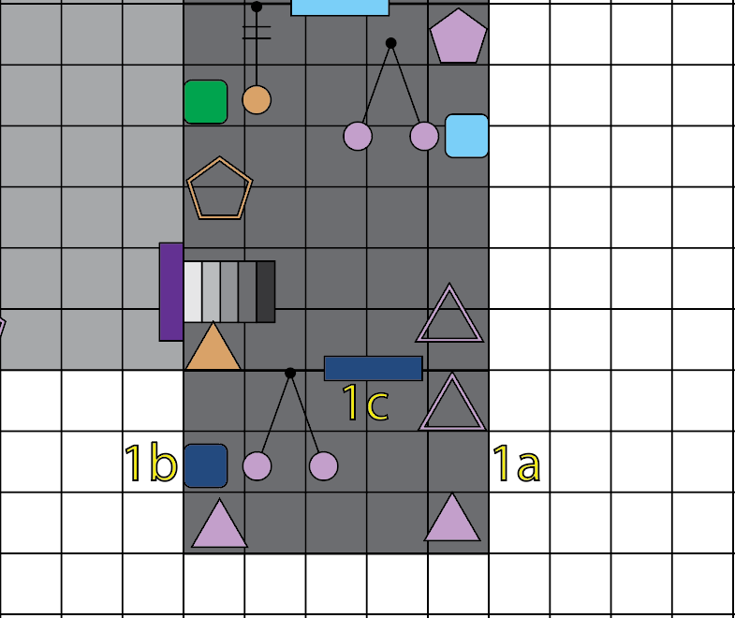

One Square = 250 cm

Figure : Room 1 Puzzle Map [2]

|  |  |  |  |  |  |
| --- | --- | --- | --- | --- | --- |
| Map Label | Event Summary | Event Details | Approx. Difficulty (1-10) | Approx. Time | Wow? |
| 1a | Player turns on pendulum | The player grabs one of the triangular prisms and places it into the triangular slot to turn on the pendulum | 1 | 0:10 |  |
| 1b | Player breaks item box | Player uses the moving pendulum to break the item box which drops the dark blue key | 1 | 0:15 | Y |
| 1c | Player enters next room | Player uses the dark blue key to open the dark blue door and proceeds to the next room | 1 | 0:20 |  |

### Room 2 Puzzle Map

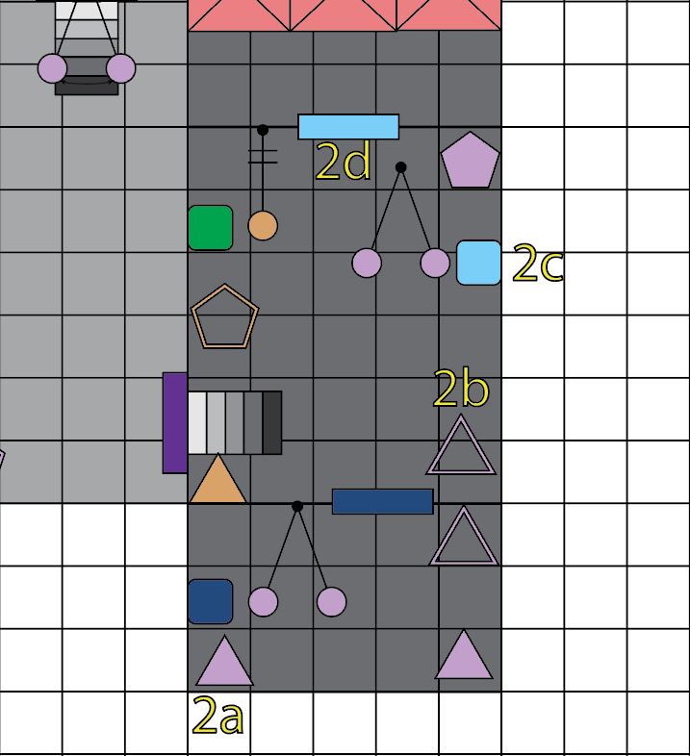

One Square = 250 cm

Figure : Room 2 Puzzle Map [2]

|  |  |  |  |  |  |
| --- | --- | --- | --- | --- | --- |
| Map Label | Event Description | Event Details | Approx. Difficulty (1-10) | Approx. Time | Wow? |
| 2a | Player retrieves triangular prism | The player goes back into the first room (after assessing puzzle) and retrieves the second triangular prism | 2 | 0:25 |  |
| 2b | Player turns on room’s east-west pendulum | Player places the triangular prism into the triangular slot and turns on the room’s east-west pendulum | 1 | 0:35 |  |
| 2c | Player breaks item box | Player uses the now in-motion east-west pendulum to break the light blue item box to drop the light blue key | 1 | 0:40 | Y |
| 2d | Player enters next room | Player uses the light blue key to unlock the light blue door and proceeds to the next room | 1 | 0:45 |  |

### Room 3 Puzzle Map

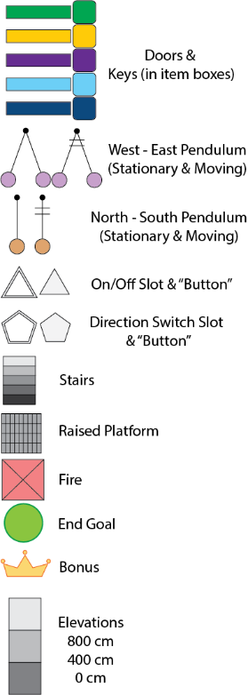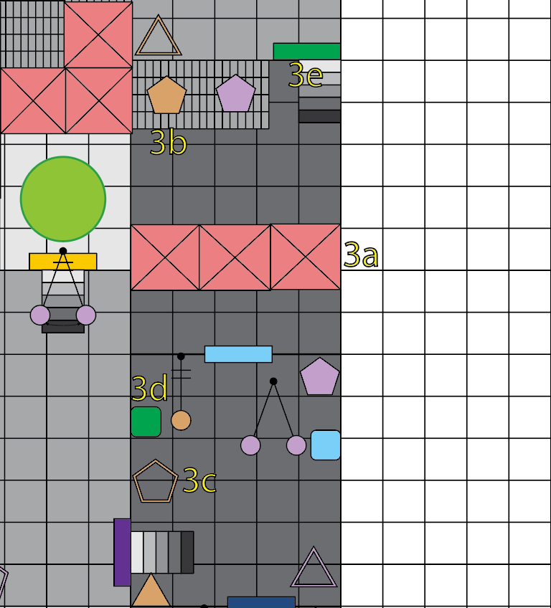

One Square = 250 cm

Figure : Room 3 Puzzle Map [2]

|  |  |  |  |  |  |
| --- | --- | --- | --- | --- | --- |
| Map Label | Event Description | Event Details | Approx. Difficulty (1-10) | Approx. Time | Wow? |
| 3a | Player crosses fire hazard | Player goes to the other side of the room by jumping over the fire hazard | 2 | 0:55 |  |
| 3b | Player retrieves north-south pentagonal prism | Player uses double jump to reach the raised platform and retrieves the north-south pendulum’s pentagonal prism | 2 | 1:10 |  |
| 3c | Player changes direction of room two’s in-motion north-south pendulum | Player returns to room two and places the pentagonal prism into the pentagonal slot changing the direction of the north-south pendulum to east-west | 1 | 1:20 | Y |
| 3d | Player breaks item box | Player uses the now in-motion, east-west pendulum to break the item box and get the green key | 1 | 1:25 | Y |
| 3e | Player enters next room | Player returns to the third room and uses the green key to unlock the green door proceeding to the next room | 1 | 1:35 |  |

### Room 4 Puzzle Map (Part 1)

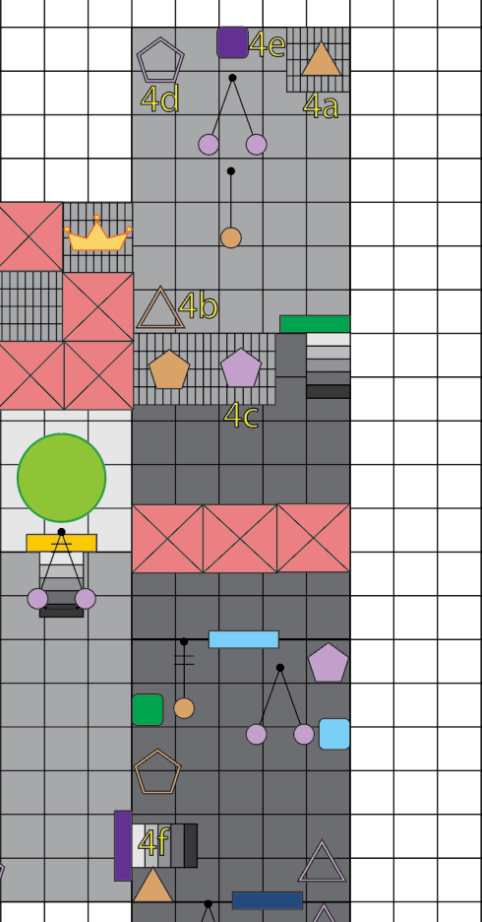

One Square = 250 cm

Figure : Room 4 Puzzle Map [2]

|  |  |  |  |  |  |
| --- | --- | --- | --- | --- | --- |
| Map Label | Event Description | Event Details | Approx. Difficulty (1-10) | Approx. Time | Wow? |
| 4a | Player retrieves triangular prism for north-south pendulum | Player uses double jump to retrieve the triangular prism for the north-south pendulum | 2 | 1:40 |  |
| 4b | Player turns on north-south pendulum | Player places the triangular prism into the triangular slot to turn on the north-south pendulum | 1 | 1:45 |  |
| 4c | Player retrieves pentagonal prism for east-west pendulum | Player returns to third room and uses double jump to retrieve the pentagonal prism for east-west pendulum | 2 | 1:55 |  |
| 4d | Player changes direction of east-west pendulum | The player places the pentagonal prism into the pentagonal slot to change east-west pendulum to north-south pendulum | 1 | 2:00 | Y |

### Room 4 Puzzle Map (Part 2)

One Square = 250 cm

Figure 7: Room 4 Puzzle Map [2]

|  |  |  |  |  |  |
| --- | --- | --- | --- | --- | --- |
| Map Label | Event Description | Event Details | Approx. Difficulty (1-10) | Approx. Time | Wow? |
| 4e | Player breaks item box | Player uses the in-motion north-south pendulum to push the stationary north-south pendulum into the item box effectively breaking it. They retrieve the purple key | 2 | 2:10 | Y |
| 4f | Player enters next room | Player returns to room two and uses the purple key to unlock the purple door before proceeding into the next room | 1 | 2:20 |  |

### A screenshot of a video game Description automatically generated with medium confidenceRoom 5 Puzzle Map (Part 1)

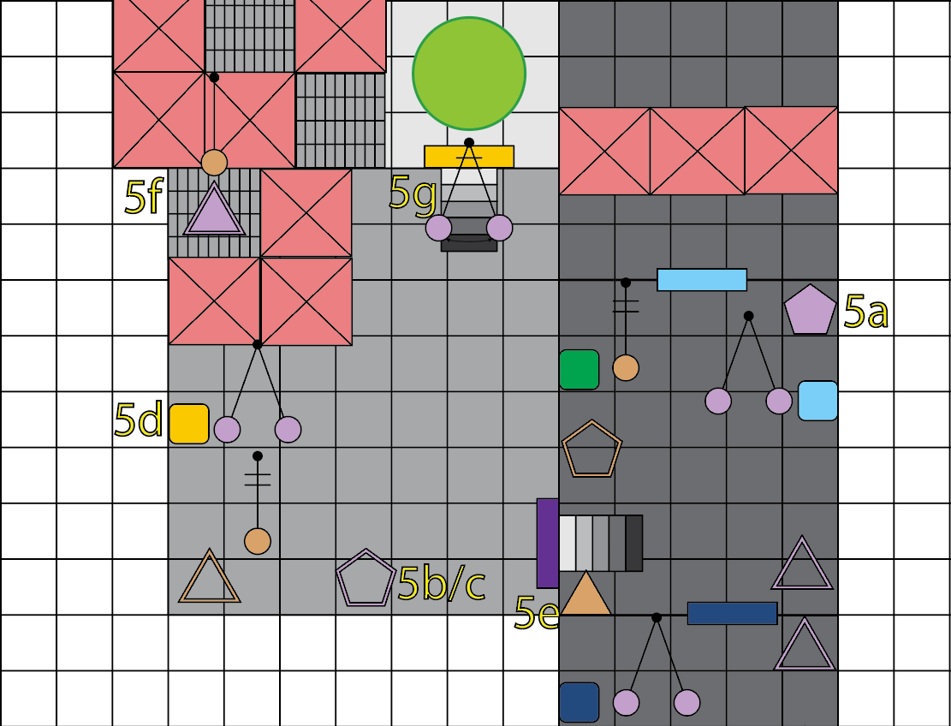

One Square = 250 cm

Figure : Room 5 Puzzle Map [2]

|  |  |  |  |  |  |
| --- | --- | --- | --- | --- | --- |
| Map Label | Event Description | Event Details | Approx. Difficulty (1-10) | Approx. Time | Wow? |
| 5a | Player retrieves east-west pentagonal prism | Player returns to the second room and retrieves the east-west pentagonal prism | 1 | 2:25 |  |
| 5b | Player changes direction of east-west pendulums | Player places the pentagonal prism into the pentagonal slot and changes the east-west pendulums to north-south. The in-motion north-south pendulum sets the newly north-south pendulum in motion | 2 | 2:35 | Y |
| 5c | Player returns previous east-west pendulums to their initial direction | After the left pendulum is in motion, the player returns it to the east-west direction | 2 | 2:40 | Y |
| 5d | Player breaks item box | Player uses the now in-motion east-west pendulum (on the left) to break the yellow item box and retrieves the yellow key | 1 | 2:45 | Y |
| 5e | Player retrieves north-south triangular prism | Player returns to the second room and retrieves the north-south triangular prism | 1 | 2:50 |  |

### A screenshot of a video game Description automatically generated with medium confidenceRoom 5 Puzzle Map (Part 2)



One Square = 250 cm

Figure 9: Room 5 Puzzle Map [2]

|  |  |  |  |  |  |
| --- | --- | --- | --- | --- | --- |
| Map Label | Event Description | Event Details | Approx. Difficulty (1-10) | Approx. Time | Wow? |
| 5f | Player knocks east-west triangular prism out of triangular slot | Player places the north-south triangular prism in the north-south triangular slot to turn on the stationary north-south pendulum. The now in-motion north-south pendulum knocks the east-west triangular prism out of its slot causing the in-motion east-west pendulum to stop moving | 2 | 3:00 | Y |
| 5g | Player enters next room | Player moves past now stationary east-west pendulum, uses the yellow key to open the yellow door, and enters the final room | 1 | 3:10 |  |

### A screenshot of a video game Description automatically generated with medium confidenceRoom 6 Puzzle Map

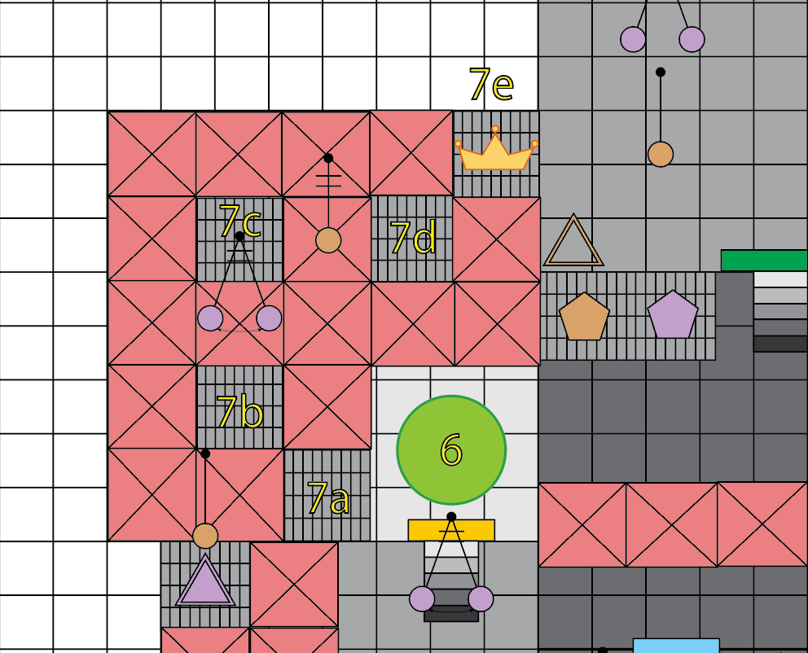

One Square = 250 cm

Figure : Room 6 Puzzle Map [2]

|  |  |  |  |  |  |
| --- | --- | --- | --- | --- | --- |
| Map Label | Event Description | Key Info (e.g. Challenges, Actions) | Approx. Difficulty (1-10) | Approx. Time | Wow? |
| 6 | Player finishes level | Player walks onto the green circle to finish the level | 1 | 3:15 |  |
| 7a | Player jumps onto first raised platform | Player uses double jump to reach the first raised platform to reach the bonus item | 2 | 3:20 |  |
| 7b | Player jumps onto second raised platform | Player jumps from the first platform to the second while avoiding the fire hazards | 3 | 3:25 |  |
| 7c | Player jumps onto third raised platform | Player jumps from the second platform to third while avoiding the fire hazards and the in-motion east-west pendulum | 4 | 3:35 |  |
| 7d | Player jumps onto fourth raised platform | Player jumps from the third platform to fourth while avoiding the fire hazards and the in-motion north-south pendulum | 4 | 3:45 |  |
| 7e | Player jumps onto fifth and final raised platform and gets bonus | Player jumps from the fourth platform to fifth while avoiding the fire hazards and retrieves the bonus item | 3 | 3:55 |  |

## Objective(s)

* To make it through 6 rooms to the end goal (and optional bonus) by manipulating pendulums to retrieve keys and unlock doors

## Hook(s)/Gameplay Highlights

* Pendulums
  + North to South movement
  + East to West movement
  + Switching directions
  + Turning pendulums on and off
* Fire Hazards
* Color-coded Doors & Keys

## Skill Progression Chart

|  |  |  |  |  |  |  |  |
| --- | --- | --- | --- | --- | --- | --- | --- |
| Skill | Room 1 | Room 2 | Room 3 | Room 4 | Room 5 | Room 6 | Bonus |
| Walk | Mastered |  |  |  |  |  |  |
| Jump |  |  | Introduced | Reinforced | Reinforced | Reinforced | Mastered |
| Double Jump |  |  | Introduced | Reinforced | Reinforced | Reinforced | Mastered |
| Turn Pendulum On | Introduced | Reinforced | Reinforced | Mastered |  |  |  |
| Turn Pendulum Off |  | Introduced | Reinforced | Reinforced | Mastered |  |  |
| Change Pendulum Direction |  | Introduced | Reinforced | Reinforced | Mastered |  |  |
| Unlock Doors | Introduced | Reinforced | Mastered |  |  |  |  |
| Breaking Item Boxes | Introduced | Reinforced | Mastered |  |  |  |  |

### New Skills/Gameplay Mechanics

#### Pendulum

The new mechanic in this level is using a pendulum to break item boxes which drop color-coded keys. There are two base variations of the pendulum: one that moves from east to west (right and left) & one that moves north to south (up and down). The pendulums that are moving east to west are lavender in color, and the north to south pendulums are a light orange color. The initial state of a pendulum can be stationary or in motion. On the maps, the in-motion pendulums are marked by two lines at the top.

##### Switching Directions

Each pendulum is restricted to one axis of movement, but there are times when the player must switch which axis the pendulum is swinging on. To do so, they must retrieve a pentagonal prism that matches the color of the pendulum that will be switched. The player then places the pentagonal prism into a pentagon-shaped slot of the same color effectively changing the direction.

##### Turning On and Off

Similar to changing the direction, to turn a pendulum on or off, the player must first find a triangular prism in the color of the pendulum to be turned on or off. They then place the triangular prism in a triangular slot of the same color.

##### Combined Usage

A moving pendulum can be used to set another pendulum in motion if they are aligned to one another. The player can turn a stationary pendulum so that it is struck by a moving one to put it into motion and then turn it again to change the direction of its movement.

## Context (N/A)

### Backstory (N/A)

### Aftermath (N/A)

## Development Schedule

|  |  |
| --- | --- |
| Milestone | Date |
| LDD | 3/23/2023 |
| Whitebox | 3/30/2023 |
| Initial Gameplay | 4/13/2023 |
| Gameplay Complete | 4/20/2023 |
| Final Deliverable | 5/2/2023 |
| RTM | 5/9/2023 |

## Aesthetic References (N/A)

### <Visual Theme 1 (replace with meaningful name of theme)> (N/A)



Figure : Contact Sheet for Visual Theme 1 (N/A)

### <Visual Theme 2 (replace with meaningful name of theme)> (N/A)

Figure : Contact Sheet for Visual Theme 2 (N/A)

## Requirements (N/A)

|  |  |  |  |
| --- | --- | --- | --- |
| Map Label | Description | Type | Priority |
|  |  |  |  |
|  |  |  |  |
|  |  |  |  |
|  |  |  |  |
|  |  |  |  |
|  |  |  |  |
|  |  |  |  |

## Key Asset Needs (N/A)

|  |  |  |
| --- | --- | --- |
| Description | Type | Priority |
|  |  |  |
|  |  |  |
|  |  |  |
|  |  |  |
|  |  |  |
|  |  |  |
|  |  |  |

# References

[Cover Image] R. Bellerose, “The Pendulum,” Israellycool, May 31, 2016. https://www.israellycool.com/2016/05/31/the-pendulum/ (accessed Mar. 23, 2023).

[1] Williams, Jaye. Map and icons made in Adobe Illustrator, Adobe, 2022. Created March 22, 2023.